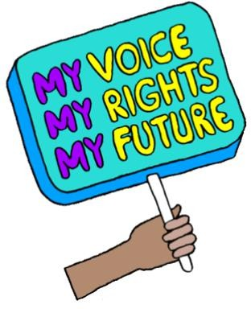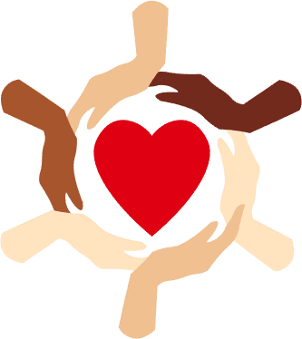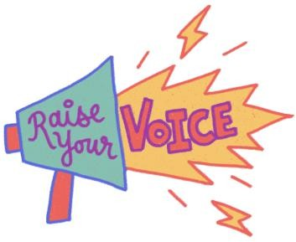

This assembly is about your rights and your voice!


5
Our pop-up exhibition
Where did the
Child Friendly
3
Leeds '12 wishes'
come from?
Children's
4
Day: Reimagined and 'Hear Us'
What are
human rights
1
and why do we
need them?
What are the 'Rights of the Child'?
2
What will we talk about today?

Let's get started…

Once you have run through the 5 points on the slide mention that children have extra rights to help their understanding of why we are talking about rights twice.

1
Why do we have them?
Something to help us all live good lives.
Something that
makes sure we are all treated equally.
Something that we all have.
Something to
protect you.
What are human rights?

Ask for hands up.....Explain what they are and that we all have them to help protect us, to make sure we are treated equally and fairly and to help us all lives good lives. Let's look back at when and why they were created......

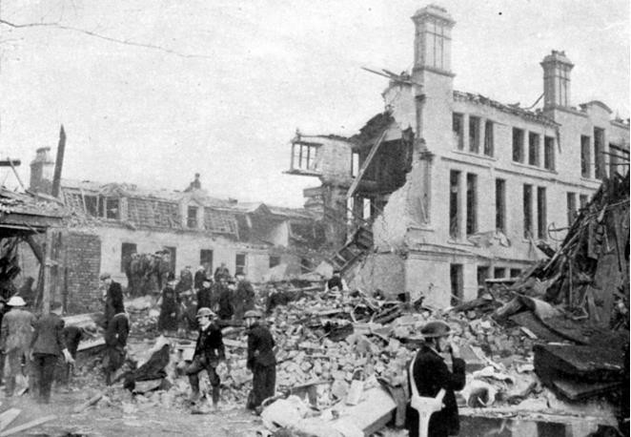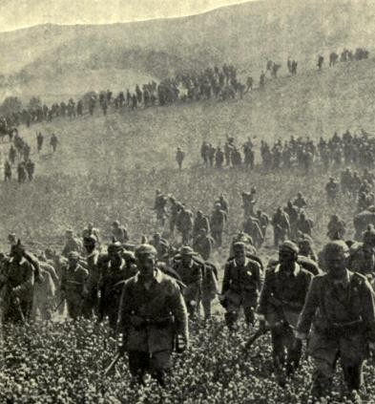
…25th April, 1945……………………………………
1
Let me take you back…

As World War II was about to end in 1945 the people across the world wanted peace. Representatives of 50 countries gathered in California and came up with the idea of forming a group, with representatives from each of the countries, which they wanted to call the 'United Nations'. The aim of having a group of people from 50 countries was to work as a team to prevent another world war like the one they had just lived through. To help achieve this they created a list of 30 human rights to recognise people's right to freedom, to make choices about their lives and to develop their potential as human beings.

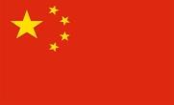 |  |  |  |  |  | 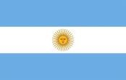 | 
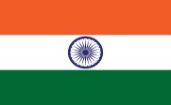 |  |  | 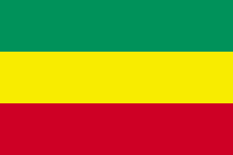 |  | 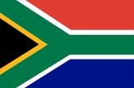 | 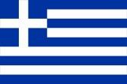 | 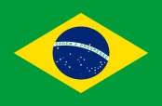

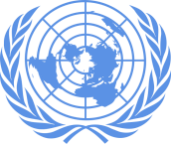
The countries that joined the 'United Nations' had to sign the agreement. Some of the countries who joined include: China, UK and Northern Ireland, France, USA, Argentina, Poland, India, Canada, Ethiopia, South Africa, Greece, Brazil. Full list here: Founding Members - UN Membership - Research Guides at United Nations Dag Hammarskjöld Library Poland joined the original 50 countries in October 1945 making the total number of partner countries 51. The United Nations created a list of 30 human rights to recognise people's right to freedom, to make choices about their lives and to develop their potential as human beings.
1
6 months later.....
…………………………………24th October, 1945…
51countries joined, including:
The 'United Nations' was
formed.

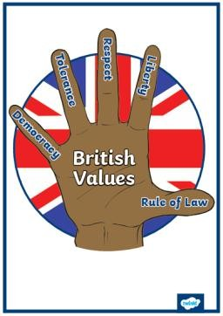
1
The United Nations (UN) Human Rights…
………………..10th December, 1948…………………

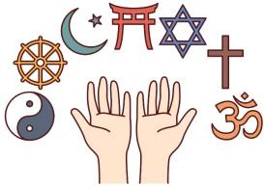



The Universal Declaration of Human Rights was declared in 1948 . There are 30 Human Rights. The images represent a few of the human rights: Everyone has the right to belong to a religion; You have the right to think and voice opinions freely; You have the right to privacy; Every adult has the right to a job.
Countries do not have to make
the rights into laws, but some do.
There are 30 Human Rights including:

In the UK, human rights are protected by the Human Rights Act 1998, so it is part of our 'rule of law' (British Values link).

2
Rights of the Child…

The 'United Nations Convention for Children's Rights' (UNCRC) was established in 1989.
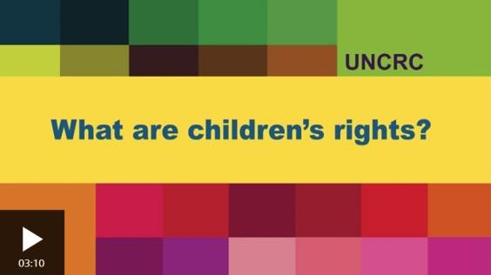
Children's Rights: What is the UNCRC? - BBC
Bitesize
…20th November, 1989………………………………

The United Nations Convention for the Rights of the Child says that every child should be recognised, respected and protected as a rights holder and as a unique and valuable human being. It applies to all persons under the age of 18.

2
Every child has 45 rights, including the right to…
a free education
a good standard of life
be protected from violence and bad treatment
express themselves
Why are these rights important?

Here are 4 examples from the 54 rights (sometimes called 'articles') that are given to children – remember a right is something that all children have, and these cannot be taken away from you.
To answer the question, encourage children to think about their history topics (e.g. Victorians, Tudors – how were children treated 100+ years ago?
The correct answer is 34 years (this is when the UN adopted the UNICEF convention of the Rights of the Child).

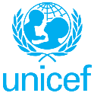
2
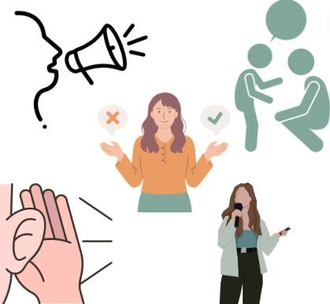
Rights of the Child…

Article 12 –
you have the right to give your opinion and for adults to listen with respect

The Rights of the Child have 54 'articles' – each one is like a rule that must be followed so that the Rights are being respected. This assembly is called 'Your Rights, Your Voice'. Looking at the pictures what do you think article 12 is all about?
You can ask children to show with their hands up if they think this is an important issue for children and young people.
Tell children that the next section about the Child Friendly Leeds 12 wishes links to article 12. Ask them to put their hand up if they spot the link.

3
What would your wish be?
How could we make Leeds the
best city to grow up in?
Where did the Child Friendly Leeds '12 Wishes' come from?

Child Friendly Leeds is a city-centre based campaign, led by the council, that aims to make Leeds a child friendly city by involving children and young people in decision-making and creating a positive environment for them. The 12 wishes, decided by children and young people in Leeds, are all about making Leeds the best city to grow up in in the whole of the UK. What would your wish be to make Leeds amazing to grow up in?
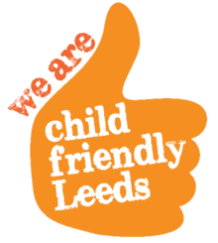

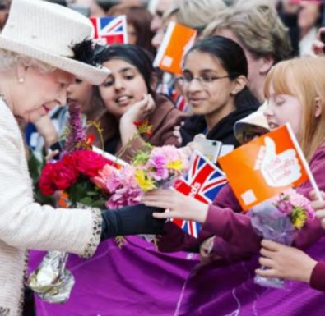
3
Child Friendly Leeds 12 Wishes…
In 2012, Leeds set out to be the best 'Child-Friendly City'!
Queen Elizabeth II visited to begin the child-friendly mission:
……………………………2012……………………

3
Child Friendly Leeds 12 Wishes…
Children's ideas were listened to and used to create the 12 wishes.

……………………………2012……………………

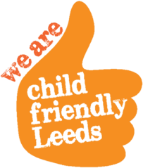
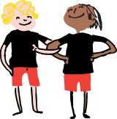
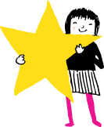
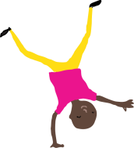
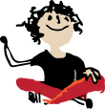

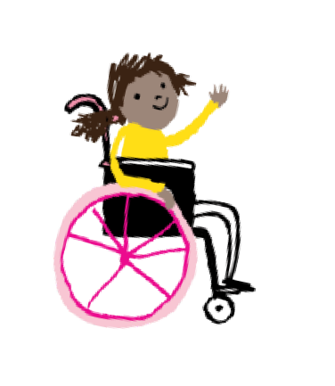
The 12 wishes are the 12 most important things to children and young people in Leeds. These 12 things are listened to and respected.

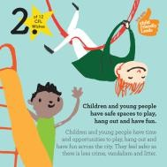
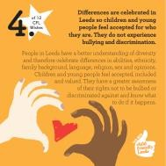
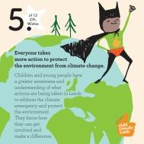
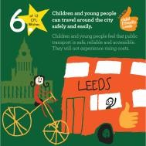
safe space
to play
safe & easy travel
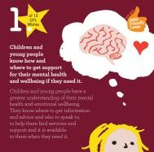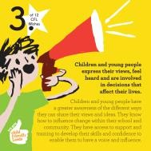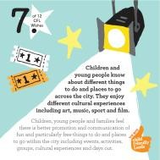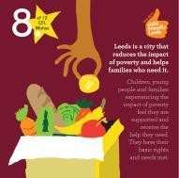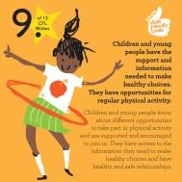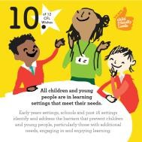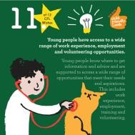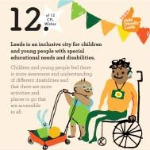
being
inclusive
3
Child Friendly Leeds 12 Wishes…
celebrate differences and anti- bullying
protect the
environment
mental health
feeling heard
reduce poverty
healthy choices
learning that meets our needs
things to do/places to go
work experience

These are the 2022 Child Friendly Leeds wishes. Each of these wishes has someone in the council who is in charge of making sure it is taken seriously. Ask children if they can see any issues up there, which are important to them.

Child Friendly Leeds hold youth voice group meetings for each one where you can go along and hear what the council's plans are and have your say. The next one is January 9th 2024.

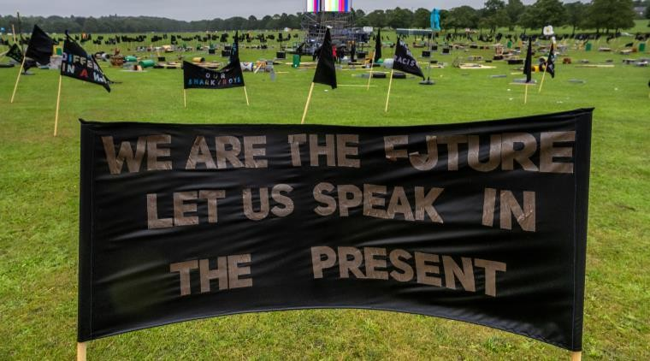
4
Children's Day: Reimagined 2023…

Children made banners expressing their hopes, fears and dreams for the future.
……………………………14th July, 2023……………

As part of the LEEDS 2023 year of cultural activities the Children’s Day: Re-imagined project was about giving children the chance to have their voice heard. The day was designed by artists, Fevered Sleep, and young people aged 11-14, who chose to create the Children’s Day: Re-imagined project with children to celebrate the children of Leeds, to hear their voices, show their power and let them tell adults about their hopes, dreams, demands and desires to change the world in future. Children were told that they could share their concerns and have their voices heard in a world that often doesn’t hear them. Kira Vaclavik, Professor of Children’s Literature and Children’s Culture at Queen Mary’s University, spoke to the children in schools about children’s rights – about their right to express their views and have their feelings and wishes heard – as written in the United Nations Convention for the Rights of the Child 1989.

4
Children's Day: Reimagined 2023…

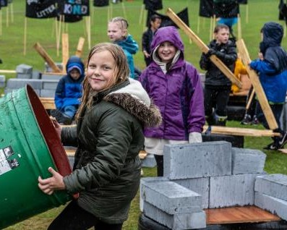
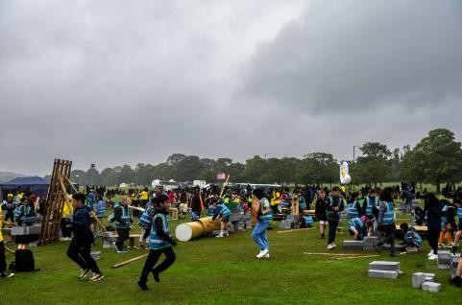
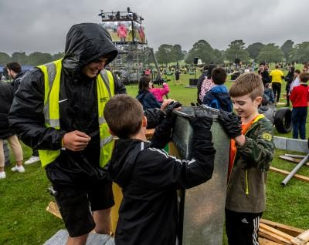
Children built dens and camps and displayed their banners (despite the rain!)…..

and watched films created by young creatives…
……………………………14th July, 2023……………

Children were told that on 14th July they would be able to install their banners that they had made expressing their thoughts and opinions, to build dens and camps, play, rehearse and sing a new song ‘Hear Us’, and listen to a young person’s samba band. Friends and family and the public would be invited to see the camp, read the banners and watch films and hear spoken word performances from young people in the evening.

4
Children's Day: Reimagined 2023…

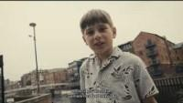

The Next Chapter - Lence | LEEDS 2023 - YouTube This is one of the films made by the LEEDS 2023 Young Creatives for Children's Day Re-imagined.

4
Children's Day: Hear Us

We want to be heard and be seen Our hopes, fears and all our dreams
No worry or panic, we can do almost anything (x2) There’s a big difference between hearing and listening Now is the time to take us seriously

'Hear us' was the song specially written and composed for Children's Day: Reimagined and we are going to learn and sing it now!

4
Children's Day: Hear Us

One, we want truth Two, we want justice Three, we want freedom Four, we want peace Five, you can trust us Six, don’t silence us

4
Children's Day: Hear Us

We’re speaking up and need to be free
We want to be heard and be seen Our hopes, fears and all our dreams
No worry or panic, we can do almost anything

4
Children's Day: Hear Us

We want to be heard and be One, we want truth We’re speaking up and
seen Two, we want justice need to be free
Our hopes, fears and all our Three, we want freedom We want to be heard and
dreams Four, we want peace be seen
No worry or panic, we can Five, you can trust us Our hopes, fears and all do almost anything (x2) our dreams
There’s a big difference Six, don’t silence us No worry or panic, we can
between hearing and do almost anything listening
Now is the time to take us
seriously

5
Let's check out the pop-up
exhibition…

