TYPES OF WATER WHEEL
A water wheel is a wheel which is turned by flowing water such as a river. They are normally used to power machinery. There are 4 different types of water wheel.
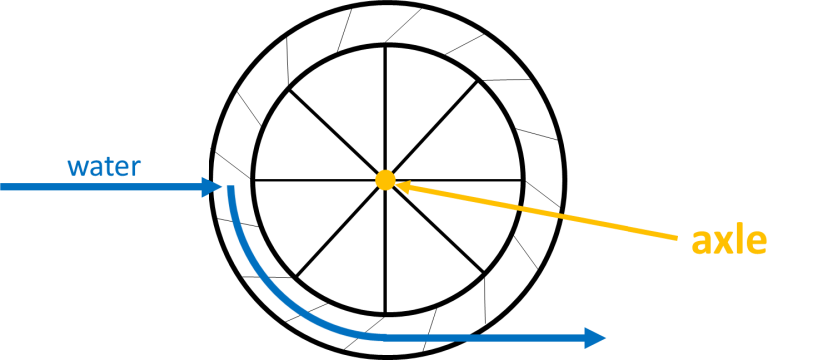
This is a ‘breast-shot’ water wheel.
A wheel is called ‘breast-shot’ if the water hits it at the same level as the axle (the centre of the wheel).

There are 4 water wheels below. Can you write the correct labels under each one?

You will need to consider where the water hits each wheel and the direction in which it is flowing.
Possible Labels
- Over-shot
- Under-shot
- Breast-shot
- Pitch-back
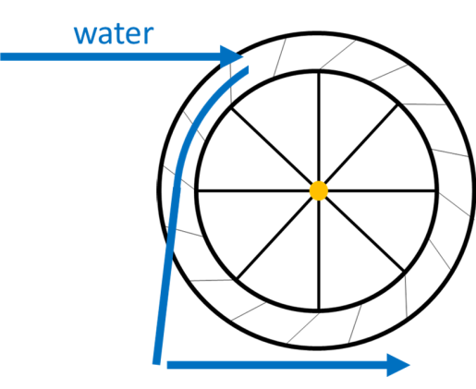
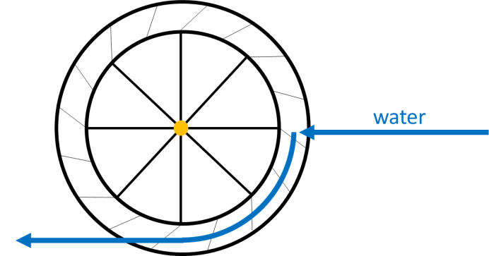
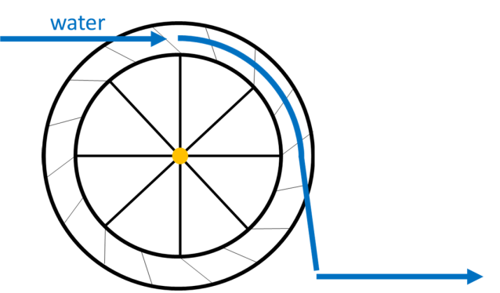
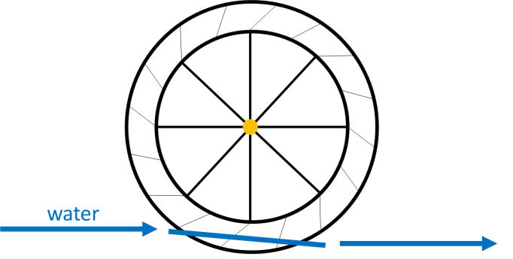
This is a/an ___________________ wheel.
This is a/an ___________________ wheel.

This is a/an ___________________ wheel.

This is a/an ___________________ wheel.
Answers
This is a pitch-back wheel.
This is an under-shot wheel.
This is an over-shot wheel.
This is a breast-shot wheel.

