POLITICS
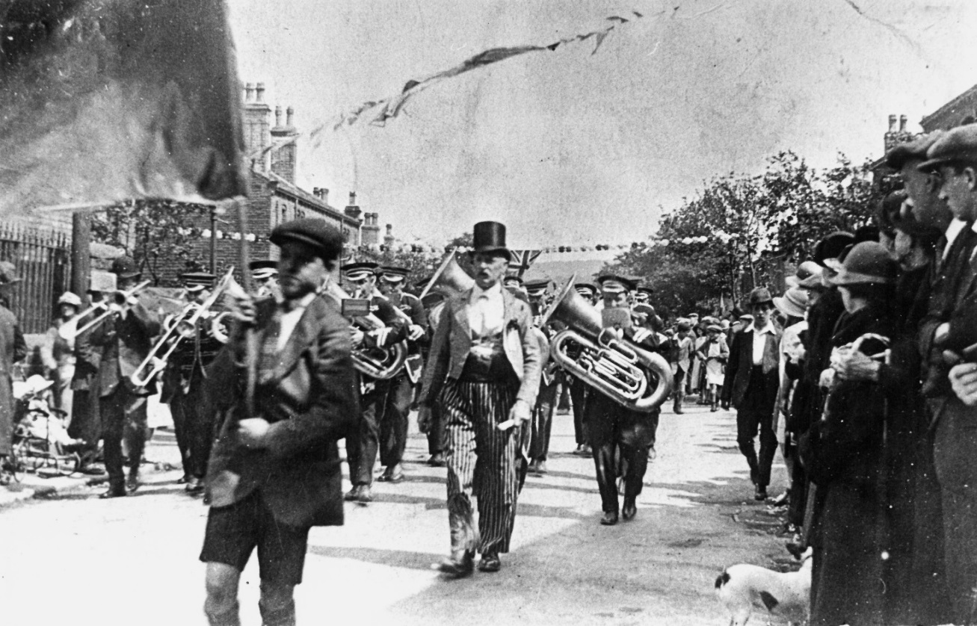

EDUCATION PACK

This pack accompanies the film “Politics” which can be viewed online at www.heritagequay.org
February 2017

CONTENTS

INTRODUCTION

WATCHING THE FILM

ANSWERING THE QUESTIONS

POST FILM ACTIVITY SUGGESTIONS

FILM IMAGES

FILM SCRIPT

FURTHER LINKS AND RESOURCES

This work is licensed under a Creative Commons Attribution 4.0 International License
Images © as attributed
INTRODUCTION
This film and pack have been developed to introduce students from KS1-3 to the political collections at the University of Huddersfield’s archives.
The archives contain many more collections than can be covered here and educators should refer to the online catalogues at www.heritagequay.org or contact Heritage Quay on 01484 473 168 or email archives@hud.ac.uk to find out more or book a visit.
This pack supports the following areas of the curriculum:
- KS1 Local History Study: “significant historical events, people and places in their own area”
Victor Grayson was a socialist politician and great orator who was the MP for Colne Valley from 1907-1910, standing for the Independent Labour Party. His fiery nature, rousing speeches and mysterious disappearance provide an ideal introduction to politics for children.
- KS2 History: “a study of an aspect or theme in British history which extends pupils’ knowledge beyond 1066”
The growth of socialism reflected in the life and work of Robert Blatchford would provide a useful addition to the non statuory examples in the curriculum, i.e. the changing power of monarchs (Victoria) or a significant turning point in British history (the industrial revolution).
- KS3 History: “Ideas, political power, industry and empire: Britain 1745 – 1901
The overarching influence of the labour movement on Britain’s political landscape is revealed through local Labour Party archives, as well of those of local politicans from the 19th, 20th and 21st centuries.

WATCHING THE FILM
The film’s narrative is aimed at KS1/KS2 children, and it also provides a good starting point for KS3 students to study British political power. We are introduced to three key figures (Robert Blatchford, Victor Grayson, J.H. Whitley) whose lives spanned almost 100 years in which the nature of the British political and social landscape was to undergo huge change.
It is suggested that teachers watch the film before showing it to students, and become familiar with the contents of this pack so that they are able to answer any questions. It may be useful for the students to have an understanding of the following: Socialism, Liberal, Labour Party, election, independent, orator, and to know the location of Colne Valley.
The film is 4 minutes 10 seconds long and includes stopping points with questions which are listed below. If the film is being used as an introduction to the topic, teachers may wish to skip the questions and return to them after the class have done some research. Alternatively, the questions can be used as a starter for discussion or a way of finding out what students already know.
The film shows Robert Blatchford, Victor Grayson and J.H. Whitley in chronological order and sets out some of their achievements and beliefs. Students are then asked questions which encourage them to undertake their own research, or consider their responses to what they have discovered.
The questions are as follows:
1:28 What can you find out about Cinderella Clubs and Whitley Councils?
2:07 Can you find some of Victor Grayson’s speeches and compare them with those of today’s politicans? What do you notice?
3:34 Which of these politicans do you think made the most signficant contribution to the labour movement? (NB. Robert Blatchford was a campaigner for social reform, not a politician).
3:39 Can you find out more about Victor Grayson’s life? What do you think happened to him?

ANSWERING THE QUESTIONS

1:28 What can you find out about Cinderella Clubs and Whitley Councils?
The Cinderella Movement was a late nineteenth century British movement to provide food and entertainment for poor children. Individuals formed "Cinderella Clubs", named after the fairy tale character Cinderella, to address specific problems associated with children's welfare. Robert Blatchford was a journalist based in Manchester, co-founder and editor of the Clarion Newspaper. He saw the poverty that existed among mill-workers resolved to do something about it. He started by writing articles encouraging like-minded readers to join him in the formation of groups who would provide food and entertainment for the children forced to live in industrial slums. They quickly became known as Cinderella Clubs. Blatchford’s activism was effective - cities throughout Britain formed their own Cinderella Clubs and much practical help was given. The Bradford Cinderella Club is still active today.
During World War I, in 1917, John Henry Whitley was appointed to chair a committee to report on 'the Relations of Employers and Employees' against the background of an emerging shop stewards movement. The smooth running of industry was vital to the war effort so maintaining good industrial relations was a priority.
J. H. Whitley proposed a system of regular formal meetings between workers and employers, known to this day as "Whitley Councils". These meetings covered issues related to pay and conditions of service, and to take matters through to arbitration if necessary. This was a strong model which was to influence industrial relations beyond the UK. Today they remain a major feature of the public sector.
The Blatchford and Whitley collections at Heritage Quay contain books, pamphlets and other original documents which provide a unique opportunity for children to carry out their own research.

2:07 Can you find some of Victor Grayson’s speeches and compare them with those of today’s politicans? What do you notice?
Victor Grayson was a popular and rousing speaker with a reputation for witty put downs when dealing with hecklers. (Many examples in the Colne Valley Guardian records at Heritage Quay). Many of his beliefs are echoed in the speeches of today’s politicians (sexual equality, abolition of the House of Lords). Some examples are given at the end of this pack. The Victor Grayson collection at Heritage Quay contains newspaper cuttings, books, pamphlets and many other records which students can investigate for themselves.

3:34 Which of these politicans do you think made the most signficant contribution to the labour movement?
Victor Grayson was a popular M.P. with the voters but his time in Parliament was short lived and he was not very active in the house. Robert Blatchford was a campaigner and writer rather than a politician and leaves behind him a publishing company and Cinderella Clubs. J. H. Whitley’s career spanned ovr 40 years and during that time he was a local councillor, Halifax M.P., Junior Lord of the Treasury and finally Speaker of the House. He was also Chairman of the Board of Governors.
Ask the children to consider what each of these men achieved in their lifetimes, how they affected the lives of others, and what remains of those achievements today.

3:39 Can you find out more about Victor Grayson’s life? What do you think happened to him?
There are many online sources of information about Victor Grayson’s life (see Further links and Resources) as well as a 1985 BBC2 documentary which can be seen at Heritage Quay. When retelling his story, ask the children to consider which information is rumour, and which can be evidenced.

POST FILM ACTIVITY SUGGESTIONS
KS1 LOCAL HISTORY STUDY: “…significant historical people in their own area” Victor Grayson’s story is an engaging one and ideal for introducing KS1 children to politics and their local history. They could:
- Re-enact Victor’s life story and imagine alternative endings
- Consider working with a local theatre group to help the children dramatise his life
- Create a handling box with props which could be used in a retelling of Victor’s life and use them as creative writing prompts
- Imagine what happened to Victor’s daughter and how she felt about her father’s disappearance

KS2 LOCAL HISTORY: “a study of an aspect or theme in British history which extends pupils’ knowledge beyond 1066”. The three characters featured in the film offer pupils very contrasting political profiles. Pupils could:
- Compare the Clarion publications, e.g. Socialism for Shop Assistants pamphlet with political campaign literature of the 21st century
- Compare Victor’s campaign promises and beliefs with those of local politicians in their own area
- Hold a mock election – which four rights would they embrace?
- Invite the local M.P. or councillor into school and interview them
- Create a timeline of Colne Valley MPs since 1910. How many were Labour?
- Find out what other members of J.H. Whitley’s family achieved
- Visit Heritage Quay and view the politics collections

KS3 HISTORY: “Ideas, political power, industry and empire: Britain 1745 – 1901
Victor Grayson was ahead of his time in promoting sexual equality. Students could:
- Create a timeline of key events in the journey towards women having the vote
- Compare some of Victor’s speeches with politicians of today. Why was it important that Victor was a good speaker? Is the power of oratory still effective today? Do they find his speeches rousing?
- Hold a campaign and lection to decide which of the 3 men had the greatest impact – Blatchford, Grayson or Whitley.

IMAGES
The images appearing in the film may be subject to copyright. They include items from the Labour Party archives, Robert Blatchford, J.H. Whitley and George Henry Wood collections, all held at Heritage Quay. They are, in order:
Victor Grayson with Robert Blatchford c. 1907
Labour party rally c. 1920
Victor Grayson, c. 1920
Robert Blatchford 1851- 1943
Advertisment for The Clarion Newspaper
J. H. Whitley 1866- 1935
J. H. Whitley as Speaker of the House 1931
Victor Grayson, 1881- disappeared 1920
Rally at Scapegoat Hill, Huddersfield c.1908
Victor Grayson speaking at a rally c. 1907
Victor Grayson voting card, showing the underlying principles in which he believed
Labour Personalities in the House of Commons 1922 – pamphlet
(Labour increased their number of seats by 85 in this election)
Declaration of the Poll 19.7.1907 Dartmouth Arms, Slaithwaite
Victor Grayson, election poster 1910
Colne Valley Guardian report about the investigation of Grayson’s disappearance 11.3.1927
Clarion Publication – The Labour Annual 1895
William Glenvil Hall, Colne Valley MP 1939-1962
The image at the front of this pack is of a Huddersfield Labour Party rally, c. 1910

SCRIPT
This film is about the politics collections in the archives at Heritage Quay. The collection reflects the growth of the Labour movement through the stories of Huddersfield men and women, who were active locally all the way to Westminster. Some rose to eminent positions in Parliament, others became well known as campaigners and writers, pushing for social change.
This is Robert Blatchford, a journalist and campaigner who did many things to try and alleviate the poverty and misery he came across in northern towns. He set up Cinderella Clubs to provide hot meals for poor children and Clarion Cycling Clubs where working people could get out into the countryside together. Robert Blatchford was an early supporter of the Independent Labour Party and founded a publishing company as well as the Clarion newspaper, which campaigned for better conditions. All of these organisations survive today.
This is John Henry Whitley. He was a Halifax mill owner who was a Liberal MP for nearly 30 years. During that time he achieved many social and industrial improvements for working people. J.H. Whitley became Speaker of the House of Commons and gave his name to Whitley Councils.
- What can you find out about Cinderella Clubs and Whitley Councils?
This is Victor Grayson. Despite having a stammer as a child, he grew up to become known as England’s Greatest Orator. Huge crowds would turn out whenever he spoke in public. He was a radical speaker, known for his rousing words and witty responses to hecklers. He supported votes for women and the abolition of the House of Lords. He was a friend of Robert Blatchford and felt passionately about the plight of working people.
- Can you find some of Victor Grayson's speeches and compare them with those of today's politicians? What do you notice?

In 1907 Victor was elected as the Independent Labour Party candidate for Colne Valley. The Labour Party had been formed the year before, and had 29 MPs in the House of Commons. They wanted Victor to join their group but he refused. He continued to make controversial speeches and once called his fellow MPs “a house of Murderers” because they refused to hold a debate on unemployment. He remained popular with the voters– he was voted Yorkshire’s most popular MP in 1908.
Victor’s parliamentary career came to an end in 1910. He founded the British Socialist Party, and tried to make a living by writing and giving lectures, but was unsuccessful. After being invalided out of the army in 1918, and following the death of his wife in childbirth, Victor was short of money. Despite this, he led a luxurious lifestyle. He dined out, smoked expensive cigars and lived in an expensive part of London. There were many rumours about how he could afford all this. In 1920, Victor was seen leaving his apartment with two strange men and carrying two suitcases. Victor was never seen again. For almost 20 years there were unconfirmed sightings of him, both at home and abroad, but his disappearance remains a mystery.
- Which of these politicians do you think made the most significant contribution to the labour movement?
- Can you find out more about Victor Grayson's life? What do you think happened to him?
You can find out a lot more about politics here at Heritage Quay.

FURTHER LINKS AND RESOURCES
http://www.cinderellaclub.org/history.php the Bradford Cinderella club
https://en.wikipedia.org/wiki/The_Cinderella_Movement the history of Cinderella clubs
http://weeklyworker.co.uk/worker/556/weapon-of-class-war/ Victor Grayson and cash for honours
http://spartacus-educational.com/TUgrayson.htm outline of Victor Grayson’s life
http://richardjonesjournalist.com/2014/11/21/lord-clark-on-the-mystery-of-victor-grayson/
“Victor Grayson: The Man and the Mystery” David Clarke, pub. Quartet 2014
http://www.parliament.uk/education/teaching-resources-lesson-plans/ lesson plans on politics for all key stages
http://www.parliament.uk/education/teaching-resources-lesson-plans/votes-for-women-1866/ KS3 lesson plans on women’s suffrage
http://spartacus-educational.com/Jblatchford.htm outline of Blatchford’s life
http://www.wcml.org.uk/our-collections/creativity-and-culture/leisure/clarion-movement/robert-blatchford-and-the-clarion/ an explanation of the role of the Clarion and many other records of the working class movement
www.phm.org.uk The People’s History Museum, Manchester, online activities and teaching resources

VICTOR GRAYSON SPEECHES:
1907 Election Address:
“I am appealing to you as one of your own class. I want emancipation from the wage-slavery of Capitalism. I do not believe that we are divinely destined to be drudges. …We have toiled in the factories and workshops to grind profits with which to glut the greedy maw of the Capitalist class…The time for our emancipation has come. We must break the rule of the rich and take our destinies into our own hands. Let charity begin with our children… the other classes have had their day. It is our turn now!”
1907 Following the declaration of the Poll outside Dartmouth Arms, Slaithwaite
“…this epoch-making victory has been won for pure revolutionary Socialism. We had not trimmed our sails to get a half-hearted vote… we stand for equality, human equality, sexual equality – for the abolition of sex ties…it is a splendid victory, comrades.”
1907 Maiden speech: in which he criticised the Government for awarding a pension to Lord Cromer “whilst outside Parliament men and women who had given good service to the state were tottering to Paupers’ graves.”
The House was due to debate a licensing act, but Victor insisted they debate the plight of the unemployed. The Speaker called him to order eight times before finally ordering him from the house. Victor called his fellow MPs "well fed human beings" and contrasted their lives with the unemployed being goaded into disorder. As he left the house, he called Labour MPs "traitors to their class." He tried to return to speak again about the unemployed and was formally suspended. This time as he left, he declared "This is a House of Murderers"

1910 Talking about the debated Old Age Pensions Act, he said that he was “in favour of 10s per week at 60, instead of 5s a week at 70.”

Victor began one speech by declaring that unlike his Liberal opponent he wouldn't quote from the Bible. "Don't know any!" a heckler shouted. Victor riposted: "I know one - the voice of the fool reaches to the ends of the earth!"

WHAT OTHERS SAID ABOUT VICTOR:
E. Jowett, chairman of the ILP
“We must recognise that the man who can make a crowd shout is not necessarily an organizer of men. The gift of platform oratory, skill in making striking phrases, is a dangerous one. It is the man behind that matters. If his skill is employed in setting, not class against class, but men of the same class against their kith and kin, sewing seeds of distrust and hatred where the love of a common cause should produce the fellowship of kindred spirits, it were better if he had no such skill."
Edward Carpenter, socialist writer
“Victor Grayson was a most humorous creature. His fund of anecdotes was inexhaustible, and rarely could a supper party of which he was a member got to bed before three in the morning. On the platform for detailed or constructive argument he was no good, but for criticism of the enemy he was inimitable - the shafts of his wit played like lightening round him, and with his big mouth and flexible upper lip he seemed to be simply browsing off his opponents and eating them up.”

