MUSIC
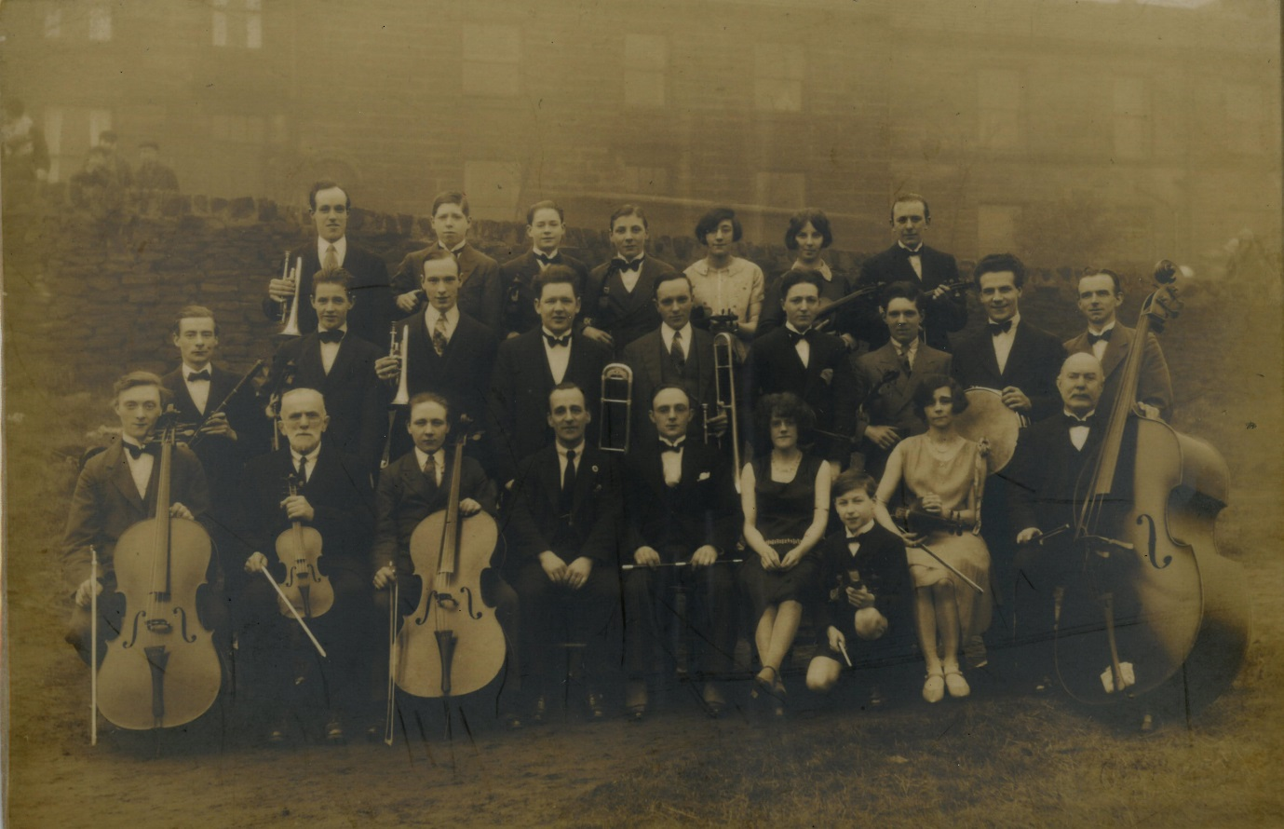

EDUCATION PACK

This pack accompanies the film “Music” which can be viewed online at www.heritagequay.org
February 2017

CONTENTS

INTRODUCTION

WATCHING THE FILM

ANSWERING THE QUESTIONS

POST FILM ACTIVITY SUGGESTIONS

FILM IMAGES

FILM SCRIPT

FURTHER LINKS AND RESOURCES

This work is licensed under a Creative Commons Attribution 4.0 International License
Images © as attributed
INTRODUCTION

This film and pack have been developed to introduce schools and home educated students to the musical collections in the University of Huddersfield’s archives.
The archives contain many more collections than can be covered here and educators should refer to the online catalogues at www.heritagequay.org/ or contact Heritage Quay on 01484 473 168 or email archives@hud.ac.uk to find out more or book a visit.
This pack supports the following areas of the Music curriculum:
- KS2: “using and understanding staff and other musical notation”
An example of graphic notation is shown and children are able to listen to the piece being performed. Suggestions are made for classroom activity to create and perform graphic scores.
- KS2: “appreciate and understand a wide range of music from different traditions”
Genres heard in the film include jazz dance and contemporary percussive music. Children are introduced to the idea that music can be used to express, inspire and reflect emotion. Suggestions for follow up activities are provided.
- KS2: “develop an understanding of the history of music”
The film gives shows different formats for recording music and gives an introduction to the development of popular music in the early 20th century. The resource can also be used to support the curriculum for Physical Education at
- KS1 and KS2: “perform dances using simple movement patterns”
Children can learn steps for one of the dances listed in the film, perhaps using the track “Happy Feet.”

WATCHING THE FILM
The film’s narrative and content are designed for children aged 5 – 11 years. It includes a variety of music recording formats and musical genres, and gives a brief introduction to popular music in the early 20th century.
It is suggested that teachers watch the film before showing it to students, and become familiar with the contents of this pack so that they are able to answer any questions. Key terms used in the film include: graphic notation, score, band leader, Black Bottom, Charleston, Foxtrot, Jitterbug. The film also shows vinyl records, a CD and cassette tape.
The film is 3 minutes 4 seconds long and includes stopping points with questions which are listed below. These can be used as a starting point for classroom activities or a way of finding out what students already know.
The questions are as follows:
0:30 Can you find out what each of these formats are?
What kind of equipment would you need to play them?
2:24 Which object would you like to write a graphic score for?
Can you find out which other everyday objects people have used to make music?

ANSWERING THE QUESTIONS:
0:30 Can you find out what each of these formats are?
What kind of equipment would you need to play them?

The question refers to the vinyl records, CD and cassette tape shown previously. Find out if these are familiar to the children, and show them images of a record player, CD player, and cassette tape player – or better still the actual items. Ask the children what other recording formats they can think of – they may know mp4 files and DVDs.

2:24 Which object would you like to write a graphic score for?
Can you find out which other everyday objects people have used to make music?
There are many examples of graphic scores in the British Music Collection at Heritage Quay, including teaching resource books for primary children. First ask the children to think about different ways of making sounds (striking, scraping, twanging), different sounds made by different materials (wood, metal, plastic), and different ways of combining these materials with how they are played (hitting metal with metal, hitting metal with wood, scraping metal with plastic).
They could then choose everyday objects which can be played in this way and write a graphic score for their piece.
A list of groups making music with unlikely objects can be found here: www.senselist.com – these include music made with vegetables, scrap metal, car parts and dustbin lids. A YouTube search will find many examples and the BBC bitesize series includes videos showing how children can make music from trash objects.

POST FILM ACTIVITY SUGGESTIONS
COMPOSING: Graphic notation evolved in the 1950s and replaces traditional musical notation with symbols and pictures. Children can:
- Learn which sounds are represented by symbols created and givenby the teacher
- Respond to those symbols depicted in a grid – practice reading them in different patterns
- Create their own symbols for different sounds and fill in a blank grid on the whiteboard
- Children can follow each other’s tunes
- Play consequences using notational symbols instead of images and play the resulting tune
- Play pass the sound – pass an invisible mimed object around the circle, the person oppostie gives the matching sound, e.g. baby crying.
Show children clips of musicians using everyday objects, including body percussion and vegetable orchestras. Tell them the story of Peter Grimes, by Benjamin Britten. They can:
- Create graphic notation for vegetables and body percussion
- Create a graphic score for “Storm” from Peter Grimes – see Further links and Resources
Such Nights by Amber Priestley (featured in the film) was inspired by the tedium endured by an office worker – hence the use of the typewriter. The title is taken from a poem by Walt Whitman. Children could:
- Choose a piece of poetry as a starting point for their own piece.
- Choose an every day object which links to their piece in some way
Children can consider the mood conveyed by Such Nights. How does it make them feel? What kind of music would they compose to make someone feel happy? Sad? Brave?
Play Soundtrack: children provide the soundtrack for a silent film. Assemble children in a circle. The conductor tells the story, and at various points, asks a member of the circle who must immediately act out the part just mentioned. Continue until everyone in the circle has a part. Next, number the children in sequence 1,2, and 3. Retell the story but this time the conductor points only to the 1s, who act the part. Number 2 is directed to make the sounds that match their neighbour’s acting.

LISTENING: Sign the class up to www.minuteoflistening.org and enjoy 60 seconds of sound appreciation every day.
Ask the children to list all the places and occasions they hear music – some are given in the film. How does music make them feel? What is their favourite piece? Favourite sound? Find out what popular music children and the rest of their family are listening to.
- Compare today’s music with popular music of the 1930s (see Further Links and Resources)
Listen to different versions of the same song, e.g. Miss Otis Regrets by
- Jay Wilbur https://tinyurl.com/h4rozys
- Kirsty McColl and the Pogues https://tinyurl.com/zlplc3j
- Linda Rondstadt https://www.youtube.com/watch?v=8gUHTjHYpLk
- Van Morrison https://www.youtube.com/watch?v=6jAqKj6i4Mg
- Bryan Ferry https://www.youtube.com/watch?v=Aw1tN0Sm4Rw
Find out what the lyrics mean – which singer do the children think best captures the mood of the song?

DEVELOPING AN UNDERSTANDING OF THE HISTORY OF MUSIC: Listen to the lyrics from other songs of the 30s, e.g:
- Home James and Don’t Spare the Horses https://www.youtube.com/watch?v=HEXR80Ut100
- Paddlin’ Madelin home: https://tinyurl.com/jfx2sov
Compare them with some of today’s lyrics. What do they notice?

Many songs/tunes from the 20s and 30s have continued to be used. Do the children recognise any of these?
Rhapsody in Blue composed by Paul Whiteman in 1924 featured in:
- Great Gatsby 2013, Fantasia 2000, United Airlines Safety video and Chicago (That Toddling Town)
It’s Only a Paper Moon, composed by Arlen, Harburg and Rose in 1933 featured in:
- Star Trek: Deep Space Nine
Happy Feet, featured in the educational video, written by Yellen and Ager in 1930 can be heard here https://tinyurl.com/hx8aase and also appeared in:
- Muppet Show 1978
- Advert for Clark’s shoes
- Strictly Ballroom 1992
Listento other music composed by Amber Priestley, e.g.
- Did Not Feel Very Well at Skool
- The Spider Woman’s Magic Formula
Compare these with the piece featured in the film (Such Nights), for which she wrote a traditional and a graphic score.
Take students on the Heritage Music Trail around Huddersfield and discover the town’s diverse musical heritage (See Further Links and Resources)

PERFORMING:
Children can:
- Perform the pieces they have composed
- Form a carrot kazoo band or vegetable orchestra and perform
Children may be familiar with many of the dances mentioned in the film from watching the TV series Strictly Come Dancing. They could learn some of the dances which were popular in the 1930s and perform the. Tutorials canbe found at:
- Foxtrot https://tinyurl.com/jf8wfo6
- Charleston https://tinyurl.com/jxa5fdp
- 1920s/30s style dance https://tinyurl.com/jensan2
Explain to the children that at the time Jay Wilbur’s band was performing, dancing was very popular, and the role of the singer was central to the success of the band, unlike today. Many pieces were purely instrumental.
Consider taking part in Huddersfield’s Mrs. Sunderland Music Festival. The archives are also held at Heritage Quay.

IMAGES
The images appearing in the film may be subject to copyright. They include items from the British Music Collection and the British Dance Band Collection. In order of appearance:

Celluloid vinyl records from the British Dance Band Collection
A collection of posters from the International Huddersfield Contemporary Music Festival
Heritage Quay archives strong room
CD and cassette tape
1920s dancing
Jay Wilburn band leader
1920s dancing (US)
Club dancing (UK)
Dancing (US)
Graphic notation score “Some Nights I get All the Free Margins” by Amber Priestly

The image on the cover of this pack is of the Huddersfield Labour Party Band c. 1920

SCRIPT
Huddersfield has a long and rich musical heritage, and this is reflected in the diverse musical collections at Heritage Quay. From dance bands to brass bands, early music to contemporary music, there are over 35,000 scores and recordings in the archives, in a range of different formats. We’ve even got records made of glass, cardboard and milk resin!

- Can you find out what each of these formats are?
- What kind of equipment would you need to play them?
Soundtrack: Happy Feet by Jay Wilbur and his band
Music can change the way you feel. The 1930s was a time of mass unemployment and hard times in the UK and people wanted to listen to music that would cheer them up. This piece of music was made in 1930. It’s called Happy Feet. The composer of this track wanted to make you feel like dancing!
During the 1920s and 30s, radio was the main source of entertainment. Almost 50% of households owned a radio in 1933. Much of the music they listened to was played by bands and broadcast live from ballrooms, restaurants, clubs and luxury hotels like the Savoy and Piccadilly in London. Dancing was very popular and there were lots of different routines to learn with names like the Black Bottom, the Charleston, the Foxtrot and the Jitterbug.
Think of all the different times and places you come across musical sounds – in films and on television, in concerts and at festivals, the ice cream van, the ring tone on a mobile phone. Some schools even use music instead of a bell between lessons.
You can make music with almost any object. This is a graphic score from the British Music Collection. It’s for typewriters. The composer has used symbols instead of musical notes. Notice how the blank space on the score matches up with the silence at the beginning.
Soundtrack and score: Such Nights I Get All the Free Margins by Amber Priestley
- Which object would you like to write a graphic score for?
- Can you find out which other everyday objects people have used to make music?
The teacher pack that goes with this film has lots of ideas about composing, playing, recording and listening to music. And if you’re stuck for inspiration, there’s much more to discover at Heritage Quay.
Perhaps one day a piece of music you’ve composed will find its way into our archives.
FURTHER LINKS AND RESOURCES
www.primaryresources.co.uk and www.teachingideas.co.uk lots of suggestions for all elements of music teaching
http://www.bbc.co.uk/programmes/articles/16ndky0F6hMWvJ3Xcbc44Dq/ten-pieces-primary -many ideas and lesson plans for teaching primary and secondary music including creating a graphic score for “Storm” from Benjamin Britten’s Peter Grimes
www.bodypercussionclassroom.com – a wealth of ideas and lesson plans
www.minuteoflistening.org offers structured, daily listening sessions of sixty seconds, backed up by activity ideas and resources.
www.growingsounds.sound101.org cross curricular workshop and collection of primary and secondary teaching resources – make musical instruments from fruit and vegetables.
www.network.youthmusic.org.uk – Tune Into Listening, an EY music resource with ideas that can be used with older children
www.youtube.com/watch?v=P6pafOJ0e9o compilation of popular 1930s music
https://soundcloud.com/amber-priestley
www.amberpriestley.com/audio.html soundtracks and scores
www.bbc.co.uk/education/clips/ztr7tfr BBC bitesize series with a wealth of lesson plans and videos for primary and secondary music teaching
http://www.discoverhuddersfield.com/wp-content/uploads/2016/10/MUSIC_reversed.pdf Heritage Music Trail around Huddersfield, from organmusic to reggae.
http://www.mrssunderlandfestival.com/ Mrs. Sunderland Music Festival open to schools and held annually in February.

NBIf you wish to perform the piece in the film, or any other piece by Amber Priestley, please email her at amber@amberpriestley.com.

