Surname | Forename | Age at death | Birth / death | Rank | Regiment | Service Number | Additional information | Questions to ask / further topics
GODSON | ARTHUR | 24 | Birth: 1895 in Beeston, Leeds  Death: 4 November 1918, (died of wounds) | Private | West Yorkshire Regiment (Prince of Wales's Own)  1st/6th Bn. | '15/381' | SON OF JOSEPH AND M. E. GODSON, OF 3, NEWPORT PLACE, HUNSLET, LEEDS  From 1901 census: Arthur’s father Joseph was a Forge Furnaceman. His father’s first wife had died and he had remarried, so Arthur had one sister, two step-sisters and a step brother.  Army records: His ‘15’ number means he was one of the first men to join the Leeds Pals.  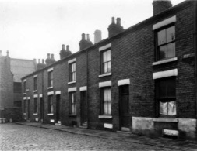  Newport Place in the 1960s | What was happening in the war in November 1918 as Arthur died?  Why is that sad?
HADDLESEY | Louis | 22 | 31 December 1916 | Private | Canadian Forestry Corps | '1038074' | Louis was born in Selby, Yorkshire in 1894.  From passenger lists: He leaves England from Liverpool on a boat bound for Quebec, Canada, in 1913 as a single man aged 20. He intends to be a farm labourer. | How does someone from Leeds join the Canadian Forestry Corps?
HARDGRAVE | HERBERT | 25 | 5 November 1918 | Private | Yorkshire Regiment  9th Bn. | ‘11299' | From CWG: SON OF JAMES HENRY AND ANNIE HARDGRAVE, OF 36, CLOVELLY TERRACE, DEWSBURY RD., LEEDS.  From 1901 census: Herbert’s father James was a bricklayer. Herbert had five brother and sisters. The family were reasonable comfortable in terms of finances as they had a live-in cook in the house.  National Roll of Honour: Herbert volunteered in August 1914 at the start of the war and was sent almost immediately to the Western Front.  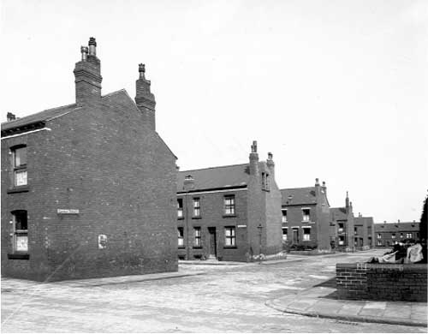  Clovelly Terrace in the 1940s | What was happening in the war in November 1918 as Herbert died?  Why is that sad?
COOK | LAWRENCE | 24 | 20 September 1918 | Private | Royal Army Medical Corps | '408003' | From CWG: SON OF MARY JANE COOK, OF 5, TRENTHAM PLACE, DEWSBURY RD., LEEDS, AND THE LATE HENRY JAMES COOK.  From 1901 census: Lawrence’s father had been a Railway Goods Checker, but he had died before Lawrence. Lawrence had two brothers. In 1901, the family had a lodger with them who probably worked with Laurence’s father on the railway. | What do you think the Royal Army Medical Corps did?  Looking just at the badge on the grave, how do you know he was in the Medical Corps?
THOMAS | JW |  | 29 June 1918 | Private | Yorkshire Regiment | '9450' | From CWG: HUSBAND OF ALICE THOMAS, OF 39, RECREATION GROVE, HOLBECK, LEEDS.  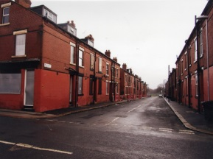  Recreation Grove in 2010 | Why do you think there is little information about JW Thomas? (common surname means it’s difficult to trace)
JONES | Sam | 34 | 28 October 1918 | Private | West Yorkshire Regiment (Prince of Wales's Own)  18th Bn. | '33360' | From CWG: SON OF THE LATE JOHN JONES; HUSBAND OF MAUD B. JONES, OF 217, ATLANTIC AVENUE, ROCHESTER, NEW YORK, U.S.A. BORN AT HOLBECK.  From 1891/1901 census: Sam’s father was a cooper in 1891 and he was the youngest of 7 children. By 1901, Sam is apprenticed to his father. Coopers would make barrels. | How do you think Maud met Sam? Where do you think they met?  What happened in the war two weeks after Sam died?
McBRETNEY | Albert | 29 | 12 July 1917 | Private | Royal Army Medical Corps | '118871' | SON OF FREDERICK ALBERT MCBRETNEY, AND THE LATE ANNIE MCBRETNEY.  From 1901 census: In 1901, Albert is 14 and his mother has already died. He is living at home with his father, his two brother and his sister. His father is a Wholesale Glue Salesman. The house keeps a servant, who would probably have done the ‘motherly duties’ of cooking and cleaning. | What do you think the Royal Army Medical Corps did?  Looking just at the badge on the grave, how do you know he was in the Medical Corps?
POPPLETON | WALTER | 39 | 13 June 1918 | Pioneer | Royal Engineers  (Inland Waterways and Docks) | 'WR/328933' | From 1891 census: Walter and his sisters, Anne and Bertha are living with the Robinson family. They are listed as the son and daughters of Francis Robinson (windower). It is likely that their father died, their mother remarries Francis Robinson, and then also dies.  From 1901 census: In 1901, Walter is a Steel Moulder and is lodging with the Spencer family on Dewsbury Road, Leeds. | What do you think the Pioneers did?
BUNKALL | Richard | 33 | Birth: KNOSTROP, WOODLESFORD, YORKSHIRE  Death:  9 November 1916 | Gunner | Royal Garrison Artillery | '6362' | From CWG: HUSBAND OF EDITH BUNKALL, OF 10, RUNSWICK AVENUE HOLBECK, LEEDS.  Richard’s father, Robert Bunkall, was the foreman of a sewage works near Temple Newsam. Richard had a sister and a step sister and brother.

