Object is found in the ground.  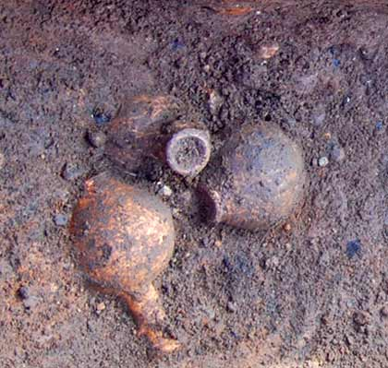 | Object is dug up from the ground.  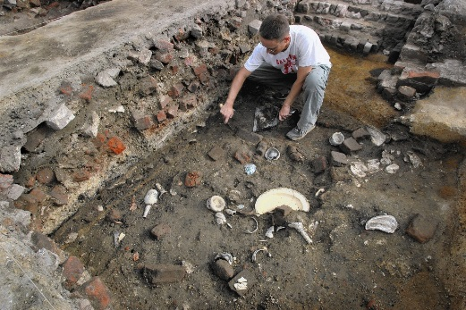
Object is cleaned and may be repaired.  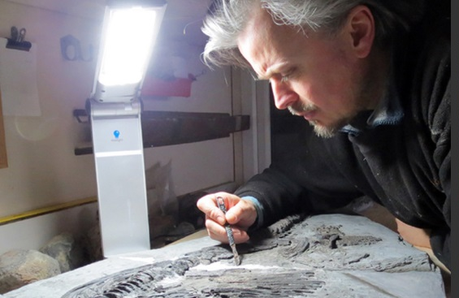 | Object is researched to find out more about it.
Object is placed inside a case at a museum.  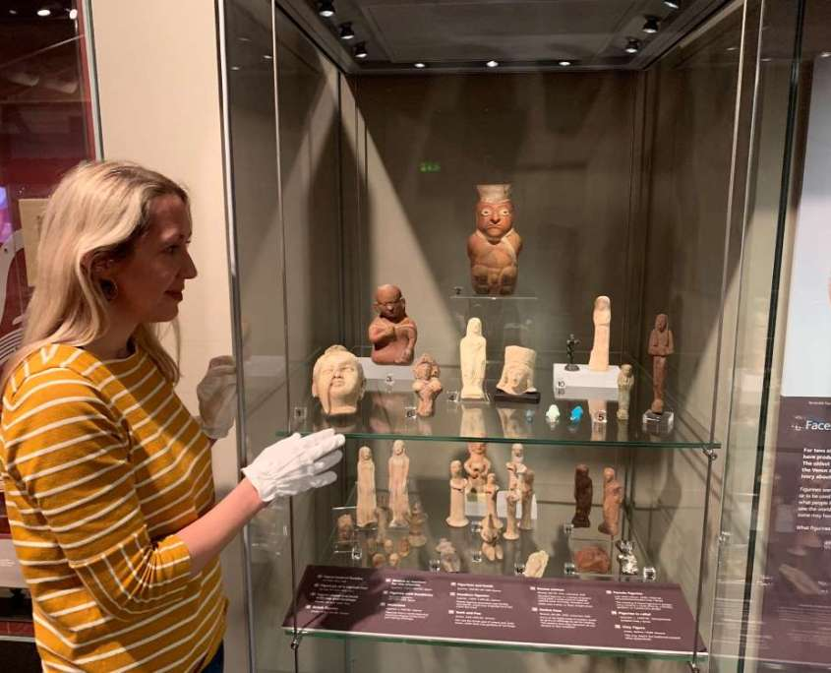 | People are told that the object is in the museum.  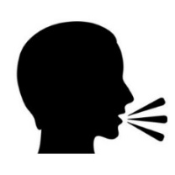
People go to see the object at a museum. | Object is underground and undiscovered.  ?

1. Object is underground and undiscovered. | 2. Object is found in the ground.  Archaeologist
3. Object is dug up from the ground. Archaeologist | 4. Object is cleaned and maybe repaired.  Conservation
5. Object is researched to find out more about it.  Curator | 6. Object is placed inside a case at a museum.  Curator/ interpretation
7. People are told that the object is in the museum.  Marketing | 8. People go to see the object inside the museum.  Front of house/ education/ learning

