
Can you match the Roman artefacts to the description?

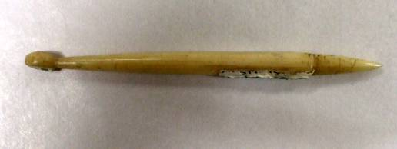
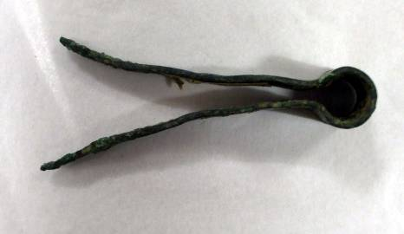
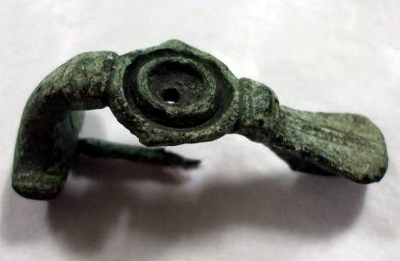
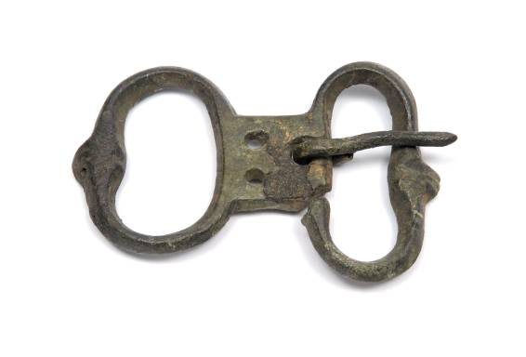
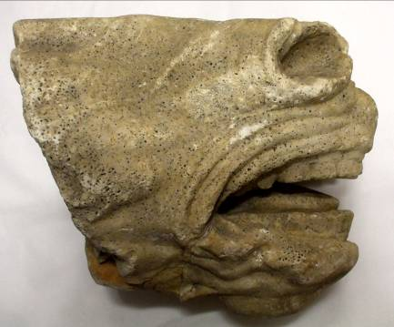
A buckle: This was used to hold clothes together.
Tweezers: Roman women would use these to remove unwanted hair from their eyebrows. They were made from bronze and could also be used a surgical instruments.
A stylus: This instrument was used to write on tablets.
A brooch: Used to fasten clothes on the shoulder.
Marble: This is part of a marble statue, used for decoration.

