

SPORT

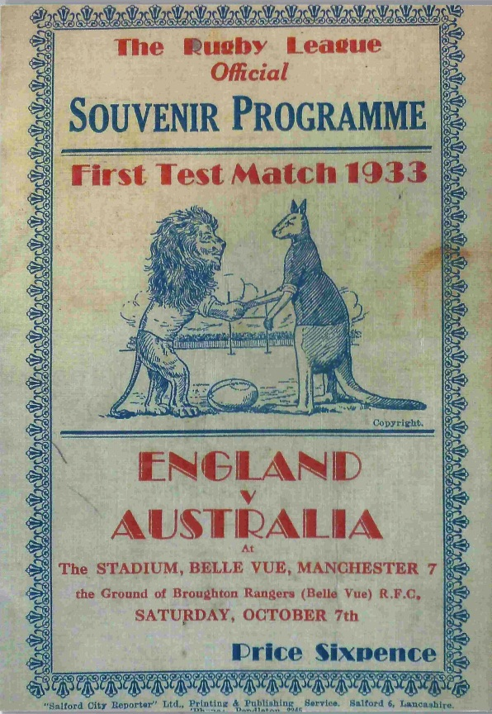

EDUCATION PACK

This pack accompanies the film “Sport” which can be viewed online at www.heritagequay.org
February 2017

CONTENTS

INTRODUCTION

WATCHING THE FILM

ANSWERING THE QUESTIONS

POST FILM ACTIVITY SUGGESTIONS

FILM IMAGES

FILM SCRIPT

FURTHER LINKS and RESOURCES

This work is licensed under a Creative Commons Attribution 4.0 International License
Images © as attributed

INTRODUCTION

This film and pack have been developed to introduce primary age children to the sports collections in the University of Huddersfield’s archives.
The Rugby Football League (RFL) was founded in Huddersfield in 1895 and Rugby League is central to the sports archive at Heritage Quay. It includes items of kit, as well as rare match programmes, advertising material and player registers and correspondence. Smaller collections on cricket are also held. More details are found in the online catalogues at www.heritagequay.org/ or you can contact Heritage Quay on 01484 473 168 or email archives@hud.ac.uk to find out more or book a visit.
This pack supports the following areas of the curriculum:
- KS1 Local History Study: “significant local events, people and places”
The role played by Huddersfield in founding Rugby League places the town at the centre of the sport’s heritage. The collection includes many photographic and other items relating to local players as well as handling sessions, making it an ideal focus for engaging children with their local history.
- KS2 Local History Study: “study of an aspect or theme in British History that extends pupils’ chronological knowledge beyond 1066”
Teachers could choose sport, leisure and entertainment as a focus theme, and study the history of Rugby League within that. The sport has its roots in the medieval game of mob football, and developed against a backdrop of privilege, the industrial revolution, an emerging wealthy middle class, the struggle for working class rights and equality of women in sport. All these elements can be found in the RFL collection at Heritage Quay.

WATCHING THE FILM
The film’s narrative and content are designed for children aged 5-11 years. It has a high proportion of visual content, making it ideal for younger pupils to engage with the subject matter. It is suggested that teachers watch the film before showing it to students, and become familiar with the contents of this pack so that they are able to answer any questions. The film is 3 minutes 1 seconds long and includes stopping points with questions which are listed below. These can be used as a starting point for classroom activities or a way of finding out what students already know.

The questions are as follows:
0:34 When do you think this rugby cap would have been worn?
0:47 What do you think its purpose was?
1:06 Can you find out why I used the words football and rugby to describe the sport?
1:10 What can you discover about the reasons behind the Great Split?

ANSWERING THE QUESTIONS
RUGBY CAP: The rugby cap belonged to Henry H. Waller of Brighouse Rangers. He presided over the meeting at the George Hotel, Huddersfield, which became known as The Great Split. It is a ceremonial cap and traditionally, every international player who represents his country receives his cap on this occasion.
The cap design stems from a match played in 1839 by the Rugby School House teams and which was attended by the Dowager, Queen Adelaide. All their players wore red velvet caps with gold tassles. In this particular match, there was a very high number of players i.e. School House (75) versus The Rest (225). The velvet cap became a sign of attainment at Rugby school and was adopted as such by clubs as a symbol of national and international achievement.

RUGBY FOOTBALL: Early football is sometimes referred to as mob football. The game would usually be played between neighbouring towns and villages, involving an unlimited number of players on opposing teams, who would fight to move an inflated pig's bladder by any means possible to markers at each end of a town. Players could pick up and run with the ball and defend their position by kicking or worse. The game was violent, injuries were frequent, and fatalities not unknown. Between 1314 and 1667, football was officially banned in England alone by more than 30 royal and local laws.
This was the game adopted by English public schools, who applied their own rules. At Rugby School, numbers of players were unlimited, and players could handle the ball but not run with it towards goal. Running with the ball was introduced at Rugby sometime between 1820 and 1830. This version of football became known as Rugby football. Other public schools had their own versions, but it was Rugby School rules which became most widespread. As the schoolboys left school, they formed clubs and associations to be able to continue playing the game as grown men. These clubs met to agree on a common set of rules.
The clubs which agreed that the ball could be handled, formed a union known as the Rugby Football Union. Some clubs disagreed with being able to handle the ball, and their version of football became known as Association Football.
THE GREAT SPLIT: When the sons of wealthy northern industrialists left their public schools and returned to their home towns to take over the business, they took with them an enthusiasm for Rugby Football. They set up or supported Rugby clubs, and men were allowed to leave the mills and factories early on a Saturday afternoon to play in matches, without deduction of wages. The game was especially popular in Lancashire and Yorkshire and the crowds could be many thousand strong. Training and diet regimes were introduced, and sometimes monetary inducements were offered to players from other towns to play for a particular team. It was suggested that the Union sanction “broken time payments”, i.e. whereby players who were out of pocket from leaving work early on Saturday afternoon, might be recompensed. The Union refused and northern clubs were accused of professionalism. A series of meetings did nothing to resolve the matter and in 1895, at a meeting in the George Hotel, 22 northern clubs decided to form the Northern Rugby Union, which became known as Rugby League in 1922. That meeting was presided over by Henry H. Waller and became known as the Great Split.

POST FILM ACTIVITY SUGGESTIONS
LOCAL HISTORY STUDY KS1: “SIGNIFICANT LOCAL EVENTS, PEOPLE AND PLACES”
The free downloadable scheme of work at www.huddersfieldrlheritage.co.uk gives lesson plans, resources and worksheets. Children could supplement the information found here with a visit to Heritage Quay and researching the original records. Pupils could:
- Research individual local players in the Pre-First World War Team of All Talents and create a biography (e.g. Rosenfeld, Wagstaff)
- Follow the Harry Wagstaff Trail around Holmfirth (see Further Links and Resources)
- Present an assembly on a Rugby League theme from the scheme of work on the website
- Identify the differences between Victorian and 20/21st century rugby kit
- Visit Heritage Quay and handle original items
- Visit the former George Hotel in Huddersfield
- Attend or perform “Broken Time” by Mick Martin

POST FILM ACTIVITY SUGGESTIONS
LOCAL HISTORY STUDY KS2: “SPORT IN BRITISH HISTORY”. The study of the history of Rugby League begins with medieval times and encompasses British social and political history, while stretching across the world to New Zealand, France and Australia. The scheme of work referred to earlier gives many suggestions for activities. Students could:
- Study popular sporting pastimes throughout the centuries
- Study the history of rugby and football side by side
- Investigate how the rules of play for football and rugby have changed
- Research the events leading up to the Great Split and the aftermath
- Study the impact of the First World War on British sport
- Compare changes in clothing, balls and protective gear 150 years apart
- Visit Heritage Quay to handle original items
- Investigate the international emblems worn by teams such as New Zealand, Australia, Wales and Scotland. What do they signify? (see Further Links and Resources)
- Research original team colours and colour in the worksheets for each team (see Further Links and Resources)
- Design their own international cap, team kit and emblems to reflect local features/signficant events
- Investigate women’s rugby and women’s football, investigating the opposition that greeted them in the late 19th, early 20th centuries and the challenges they overcame to participate in the sport

IMAGES
The images appearing in the film may be subject to copyright. They include items from the RFL archive, which holds a range of items, including minute books, players’ kit and programmes. In order of appearance:

Henry Hirst Waller’s cap 1890 – Brighouse Rangers Football club
Images of Rugby players on silk – probably used in cigarette card promotional material c. 1920
Shin pads and shoulder protection from the Dai Jenkinson collection
Idris Towill, who was capped for Wales while playing at Huddersfield in 1932
Jim Valentine, 1866- 1904. Jim’s career with the club straddled the Great Split so that he played for the Swinton Lions under two codes – Union and League.
Yorkshire Senior Competition Shield 1892
Cartoon 1890s “The Rugby Rumpus” depicting the struggle between amateurism and professionalism, personified by Reverend Frank Marshall and A.J. Millar of Yorkshire, who opposed and proposed broken time payments respectively.
20th century match tickets and promotional material
Drawings at the end of this pack by M. Fox

The image on the cover of this pack is of a programme from the 1933 Test Match between England and Australia.

SCRIPT
We’ve got lots of sporting items at Heritage Quay. The Rugby League Collection is very special, because Huddersfield is where the sport began over 120 years ago. Today it is played all over the world.
The person who owned this rugby cap played an important part in the founding of Rugby League. His name was Henry Hirst Waller. He played for Brighouse Rangers over 135 years ago. Let’s take a closer look at it.
- When do you think this rugby cap would have been worn? These letters– BRFC -stand for Brighouse Rangers Football Club. It doesn’t offer any protection. It’s made of velvet and the tassel wouldn’t last long in a match. It looks a bit like an old fashioned schoolboy’s cap.
- What do you think its purpose was?
Henry Waller was the chairman of a very important meeting that took place in the George Hotel in Huddersfield in 1895. This became known as the Great Split where the modern game of Rugby League began.
- Can you find out why I used the words football and rugby to describe the sport?
- What can you discover about the reasons behind the Great Split?
These are some of the rugby clubs who attended the Great Split meeting in 1895 at the George Hotel. Rugby developed from a type of football that was very different from today’s game. There were no rules to speak of, no limit on team size, and there wasn’t even a proper pitch. The game was violent, often resulting in injuries and even deaths. It was known as mob football.
Mob football was popular at English public schools, who each made up their own rules. At Rugby School, boys were allowed to run with the ball so their version became known as Rugby Football. After featuring in the book Tom Brown’s Schooldays, it became very popular throughout the country, with lots of towns setting up their own Rugby Football clubs.
Rugby Football was played on Saturday afternoons, a working day and some clubs paid players to make up for lost wages. These were called Broken Time payments. Rugby’s governing body was dominated by southern clubs and many of their players didn’t need to work on a Saturday. They threatened to suspend clubs which paid Broken Time payments. The Northern clubs at the Great Split meeting were in favour of these payments.
After the split, Rugby developed into two different sets of rules, or codes – Rugby League and Rugby Union. Both codes introduced many changes to the way the game was played. Rugby Union remained an amateur sport while Rugby League players became professional.
Rugby Union players remained unpaid until August 1995 - 99 years and 364 days after the Great Split meeting, chaired by Henry Hirst Waller.

FURTHER LINKS and RESOURCES
http://www.rugbyfootballhistory.com/originsofrugby.htm all you ever wanted to know about the history of rugby league
https://www.theparisreview.org/blog/2016/02/11/northern-powerhouse/ a review of David Storey’s This Sporting Life and placing the game of rugby in a social context
https://library.biblioboard.com/content/78e3479a-0868-46b4-9ded-6a2639ada841 analysis of the “Rugby Rumpus” cartoon
http://www.huddersfieldrlheritage.co.uk/Education/Education.html a wealth of information and photographs, and free teaching resources including a full KS2 scheme of work about Rugby League
http://www.huddersfieldrlheritage.co.uk/Documents/Trails/WAGSTAFF%20TRAIL.pdf Wagstaff Trail
http://www.scratchingshedpublishing.com/products-page/scripts/broken-time-the-complete-script/ Playscript for purchase “Broken Time” by Mick Martin
https://www.youtube.com/watch?v=kkNnvXDxVMM Trailer for “Broken Time”
http://www.rugbyrelics.com/Museum/topics/womens-rugby-history.htm History of women’s rugby
http://library.la84.org/SportsLibrary/FootballStudies/2001/FS0402e.pdf An account of women’s role in rugby, including the famous 1921 Sydney match.
These are just a few of the many resources available online. Individual clubs often have their own heritage resources or information.

Finish the pictures of the players with their team colours – choose from 2015 or 1922 kits
TEAM 1922 2015
Batley green, white & blue cerise & white
Huddersfield red & yellow claret & gold
Hull K.R. red & white red & white
Leeds blue & white blue & white
Salford red & white red
St. Helens blue & white red & white
Widnes chocolate & white black &white,
lime green trim

Wigan cherry & white hoops cherry & white
Warrington blue & yellow primrose & blue
Hull City black & white hoops
Bradford yellow, black, red
Halifax blue & white hoops, blue & white socks

Dewsbury black, crimson, yellow
Castleford amber, black, white
Wakefield white, red, blue
Hull F.C. black, amber

