Career Profiles
Who am I?  I am James | 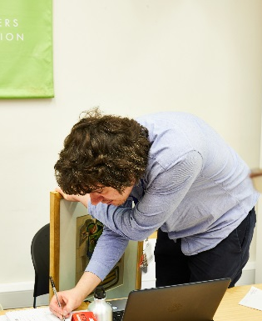
What is my job?  I am a Membership Assistant at the Leeds Discovery Centre and Leeds City Art Gallery. | 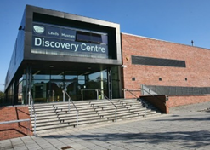  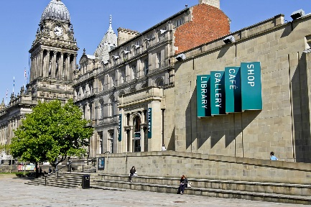
What do I do in my job?  - Help people join our Picture Library and School Membership Scheme.  - Carry out the administration (admin) for the Picture Library and the School Membership Scheme.  - Help the Learning and Access Officer at the Discovery Centre to create and manage the membership scheme.  - Help the Curator at the Art Gallery to look after the artworks that go out on loan and decide how to further the scheme. | 
How did I get my job? / My background.  I’ve always worked in an administration.  I got into museums in 2010 when I started working at Red House Museum in Gomersal as an Attendant.  I joined Leeds City Council in 2013 when I started working at Lotherton Hall as a Visitor Assistant.  I started my current role in January 2019. | 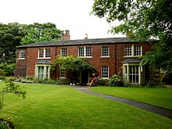
What I like about my job?  - Working in a great team  - Knowing my job contributes towards children’s learning.  - That my job has variety | 
Advice on how to get into a job like mine  - Don’t be scared to apply for a job at a museum even if you have no background in the area.  - Be passionate  - Work hard | 

Who am I?  I am Emma. | 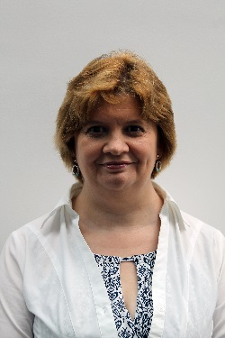
What is my job?  I work as a conservator for Leeds Museum Service looking after the collections on display, in storage and on loan. | 
What do I do in my job?  - Talk to the public about my role.  - Look after the environmental conditions across a number of sites for the safe storage and display of our objects.  - Care for objects including cleaning them.  - Fix broken objects.  - Do condition checks on objects and give recommendations on how they should be displayed.  - Work with conservation volunteers and conservation students on projects.  - Do training courses for staff.  - Collate pest information from our sites. | 
How did I get my job? / My background.  - I trained in archaeological sciences at university and did a module on conservation.  - I then did another university course in Conservation of Historic objects.  - I had placements at York Archaeological Trust, Doncaster Museum, and the Bradford University Conservation Lab.  - Once I gained these qualifications I was able to start work in conservation.  - My first job was for six months at the Conservation Centre in Liverpool.  - My second job was at the Manchester Museum of Science and Industry.  - My third job was here at Leeds, I started on an 18 month contract and I have now been here for over 16 years. |     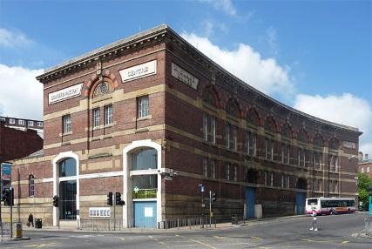  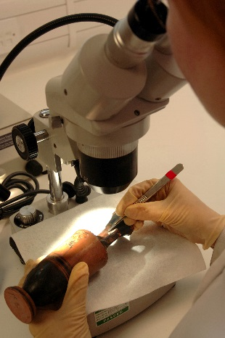
What I like about my job?  - Working with historic objects.  - Working in the heritage service and looking after objects for next generation.  - Working with volunteers and students.  - Working with a wide range of people.  - No two days are the same.  - Working across so many different sites in Leeds.  - Learning to use the Cherry Picker in the store. | 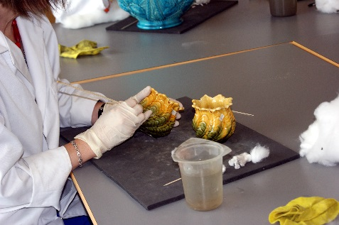
Advice on how to get into a job like mine  - Be passionate about caring for history.  - Volunteer.  - Study hard and get the appropriate qualifications. | 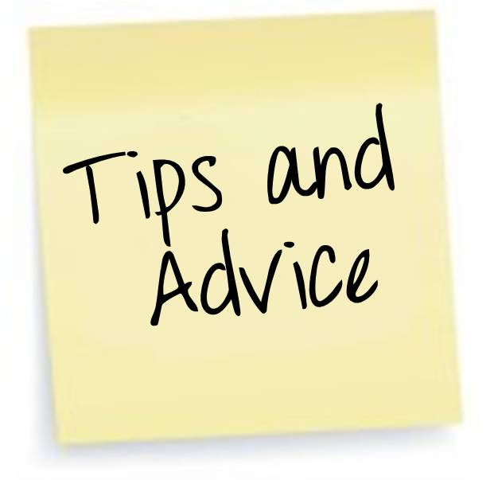

Who am I?  Danielle | 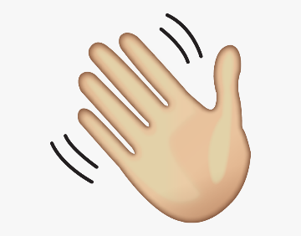
What is my job?  Visitor Information Host at Visit Leeds and Art Gallery Shop | 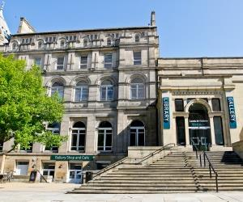
What do I do in my job?  Give advice to tourists/residents about Leeds.  Work in the Art Gallery shop serving customers. | 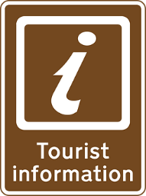
How did I get my job? / My background.  I have customer service experience and have previous experience working in a shop | ?
What I like about my job?  Meeting and talking to new people. We have a lovely team! | 
Advice on how to get into a job like mine  Have good communications skills, learn good customer service skills. | 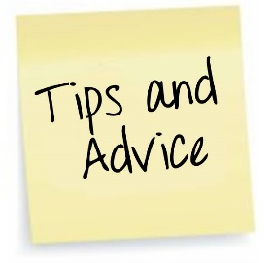

Who am I?  Andrew Bodley | 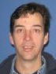
What is my job?  Senior Engineer | 
What do I do in my job?  - Look after and run working machinery, steam crane, steam engines, water wheels.  - Build displays and exhibitions for the museum.  - Repair, conserve and restore items in our collection for preservation, display or use.  - Help solve issues around the building, ie put up shelves, build furniture. | 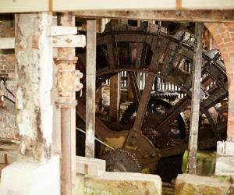
How did I get my job? / My background.  I like making and repairing things. At school I did wood work and metal work classes.  I’m interested in history.  I volunteered for a museum then began working there helping curators.  From this experience I understood how museums look after and care for their collections. | 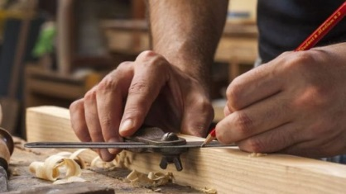
What I like about my job?

The variety of the work is interesting. Every week is different. I need to learn new things and use lots of skills in my work.
Advice on how to get into a job like mine

Learn different skills in making or repairing things (metal, wood, plastic or leather). Learn about how museums care for their collections.

Who am I?  I am Carl | 
What is my job?  I work at the Leeds Discovery Centre as a Learning and Access Officer on a project called Careers for all. | 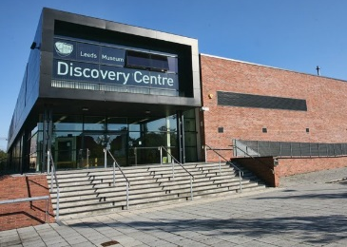
What do I do in my job?  - Talk to pupils about jobs in Museums.  - Promote STEM (science, technology, engineering and maths) careers.  - Organise and run work experience for young people age 16-25  - Write and deliver career taster days, which give people the chance to learn about careers and gain skills that could be taken into a job.  - Go into schools as a visitor to talk about jobs in museums. | 
How did I get my job? / My background.  I trained to be a teacher but instead of working in a school I taught people in museums.  I volunteered to gain some museum experience. My volunteering then led to a job as a museum guide.  I then joined the Learning Team at the Royal Armouries where I wrote and taught workshops for children and young people who visited the site.  I moved to Leeds Museums in 2019 to do the job I am in now! | ?
What I like about my job?

- Meeting lots of different people
- Helping others with their future
- Working in a team

Advice on how to get into a job like mine

- Be passionate
- Volunteer to gain experience
- Be a good communicator
- Know your job. For me this is staying up to date with what schools and employment agencies are doing.

Who am I?

Hello, I am Errin

What is my job?  I am the archivist working for Leeds Museums & Galleries. I take care of the archive materials we have across our 9 Leeds Museum sites. | 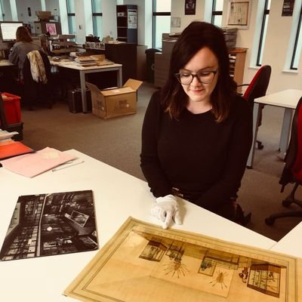
What do I do in my job?

- Take care of archive material across the service. This is paper-based material such as letters, photographs and other important, historical douments.
- Catalogue records in the Archive of Sculptors Papers
- Give public access to these archvies
- Help pick new archives that come into the collection

How did I get my job? / My background.  I studied History at University and was always using really interesting and fun archive materials in my research.  Archives are so diverse and archivists can work with a big variety of records. My previous jobs have included the Archive for Carnival Arts and the British Stand-Up Comedy Archive. | ?
What I like about my job?

I really love to find out new and interesting facts when I am cataloguing documents.

I also really like to be able to give access to these records to researchers and get to show them things that very few people have seen.

Advice on how to get into a job like mine

Volunteer first to see if you like the job and to see what parts of it are your favourite.
Think about what you can bring to a job like this. Everyone is unique and can bring something fun to a creative career.
Don’t be afraid to share your great ideas.

Who am I?  I am Megan | 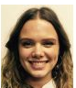
What is my job?

I am the Digital Engagement Officer for Leeds Museums & Galleries. I am in the Audience Development team.

What do I do in my job?  - I post on our @LeedsMuseums social media accounts, and come up with plans and strategies for what kind of things to post in future  - Help each of our 9 museum venues to organise how they run their social media accounts  - Add content to our website  - Send email newsletters  - Create adverts to run online  - Create videos to use on social media  - Report on who are online audiences are, and what things they like to hear from us  - Research new ways to engage with our online audiences  - Manage the podcast “Museums n’that” |   
How did I get my job? / My background.  I studied English Literature and History at the University of Leeds. When I was there, I realised I wanted to work in museums.  I worked in a coffee shop and volunteered at Abbey House Museum and Harewood House on my days off.  The friends and contacts I’d made volunteering encouraged me to apply for a paid Social Media Placement.  When on the placement, I applied internally for the job I’m in now. The timing worked out very well! | ?
What I like about my job?

- Doing different things every day – it’s never boring
- Working with a great team and making friends
- Having conversations with interesting people and other museums who follow us online

Advice on how to get into a job like mine

- Be friendly, approachable and interested in other people’s work
- Volunteer
- Take any opportunity if it’s a step in the right direction

Who am I?

Milo Phillips
What is my job?  I am the Assistant Curator of Entomology and I’m working on a project called Dead Inspiring | 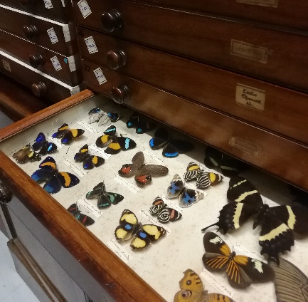
What do I do in my job?  - I look after thousands of insects in the collection and make sure they are accessible to everyone who might want to see them.  - I promote women-in-science and develop projects to encourage young women and girls to get involved with the natural sciences through.  - I will work with volunteers to curate the collection and communicate science in loads of different ways using our wonderful bugs! | 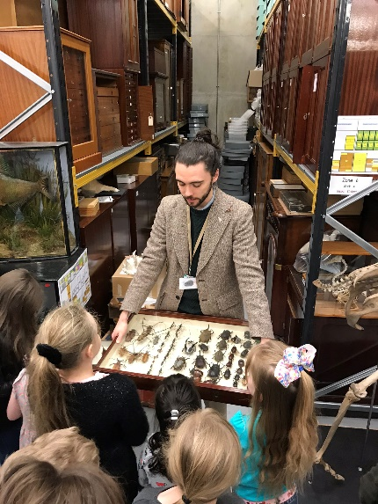
How did I get my job? / My background.  I worked as a Ranger at Wellington Zoo in New Zealand, which gave me lots of experience communicating science to all sorts of people.  I then studied Ecology at university, where I learnt more about entomology and had a chance to work closely with insects in the field and in the lab.  I volunteered as a lab assistant during my degree, did database work for researchers and even looked after the university bee hives. I also worked every weekend at the Royal Armouries as a museum assistant, helping introduce visitors to the huge collection there.  After graduating I got a job as a research assistant in one the labs I had volunteered in, working with social insects.  In 2020 I started the job I’m in now, which pulls together all the experience I’ve gained so far! | 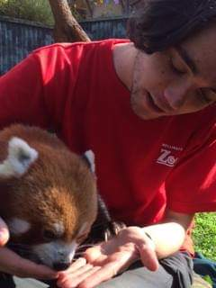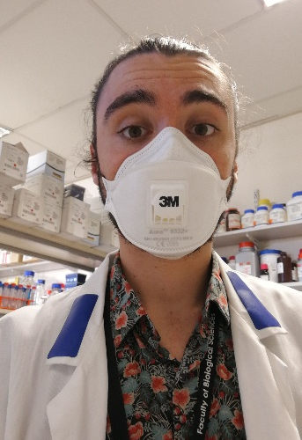
What I like about my job?

- Getting hands on with so many amazing objects.
- Learning new things every day.
- Helping to promote equality in science.

Advice on how to get into a job like mine

- Volunteer as much as you can
- Don’t be afraid to try lots of different things. I didn’t know I wanted to work with insects until I’d almost finished my degree, before that I worked with parasites, coral reefs, and even sea urchins and algae!
- Experience in communicating well and with lots of different groups is just as important as the museum experience. You can be an expert in something, but a big part of curating is being able to inspire people with that knowledge.

Who am I?  Vanessa Jones | 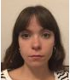
What is my job?  Assistant Curator of Dress and Textiles | 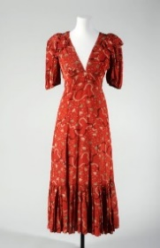
What do I do in my job?  Look after the 20,000 dress and textiles in our collection. I make the collection accessible to the public, research objects in the collection and plan exhibitions. | 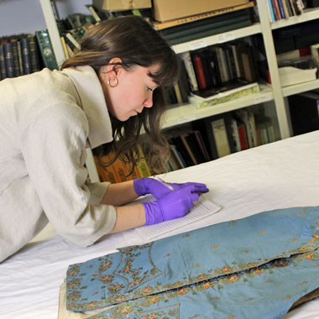
How did I get my job? / My background.  I have an undergraduate degree in geography. I started volunteering at a National Trust property and a local historic house, with a specialist interest in fashion and historic dress. I then started volunteering at the V&A museum on a specific publication.  I started my own curatorial youth group, which I got funding for. I taught young adults museum skills and we put on an exhibition.  I volunteered for 3 years before I got my first ‘real’ job in the sector and it took another 2 years to land a job as a curator. | ?
What I like about my job?

Meeting new people and object based research!

Advice on how to get into a job like mine  Volunteer!  There are lots of roles in a museum, sometimes these are roles people don’t often hear about. Sometimes people think they want to go into curatorial work when really they would be better suited to an engagement officer, conservator or even volunteer coordinator!  Get experience in a small museum and try out different sorts of roles.  Get some project management experience too!  If you really do want to go into a curatorial position, figure out a specialism. What gets you excited?  Join subject specialist networks and groups and build relationships in your desired field. And go to conferences! | 