Mary Bateman Story Activity

Read the story of Mary Bateman and listen to the ballad about her at www.365LeedsStories.org. Now, break the story down in to its separate parts – There is a simplified version of the story below. You could split the class into small groups and give each group a different part of the story. The task is to retell each part in words and pictures. The class might:

- Draw these using paper and pencil crayons to make a comic strip version.
- Use black card, white pencil crayons and scissors to cut out silhouettes like the ones below
- Use OHP acetates and pens to make transparent “stained glass images”.
- Use modelling clay to create characters and objects
If you decide to make silhouettes or acetates pictures, you can use torches, lamps or Overhead Projectors to project them onto a screen or a wall. If you use modelling clay, you could create a 3D frieze, or use a camera to take still images and turn them into a stop motion film.
Story breakdown
- Mary Batemen was born in Aisenby in North Yorkshire in 1768. From the age of 12, she worked as a servant in several big houses in the local area. She didn’t stay long though as she was often accused of stealing and making mischief.

- At the age of 19, she went to Leeds and worked as a gown-maker. At 24, she met and married her husband, Richard. They had only known each other for four weeks. Over the next few years, Mary gained a reputation. She worked as a fortune teller and seller of charms. People were very superstitious in those days and Mary found it easy to con people.

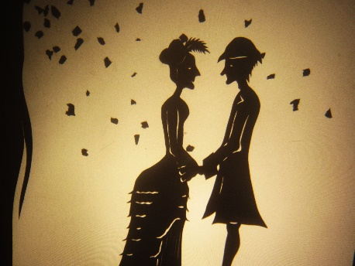
Image created by Reb Caputo

- Mary once forged a letter to her husband, telling him that his father was dying and that he must go back to his home village of Thirsk. Her husband left and while he was away, Mary sold all the furniture in their house to pay off her gambling debts.

- Mary once claimed that one of her children had died in a fire in a local factory and asked people to give her linen sheets to wrap his body in. Later, she pretended to be a nurse from the infirmary and again asked for linen for the hospital. She sold what she was given and kept the money.
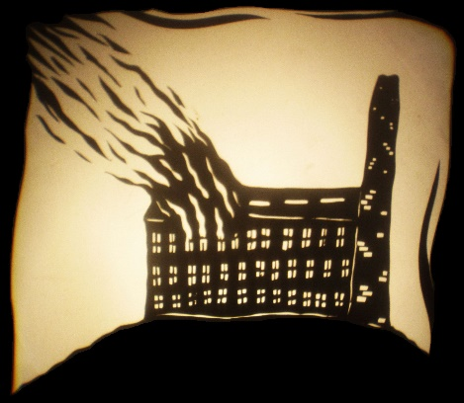
Image created by Reb Caputo

- Mary had a hen, which she said could predict the future. It laid eggs with messages from God on them. One of the eggs said “Christ is coming.” People thought it meant the world would end but, in fact, Mary had written the message herself and pushed the egg back inside the chicken.
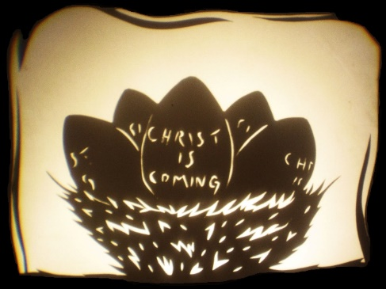
Image created by Reb Caputo

- In 1805, she met a couple called the Perrigos, who lived in Bramley. Rebecca Perrigo was suffering from a “fluttering in her chest” and they asked Mary for advice. She told them she would write to her friend “Miss Blythe” in Scarborough, who knew all about magic.

- “Miss Blythe” made the Perrigos give her money and lots of things from their house. These were taken by Mary Bateman. In return, she told them to make charms out of guinea notes and sew them into the cover on their bed.

- Later, “Miss Blythe” told the Perrigos to eat a special pudding, which would prevent them both from being ill. They had to put in some special powders she had given them. The powder contained poison and Rebecca Perrigo died.

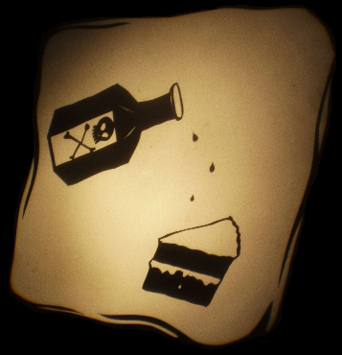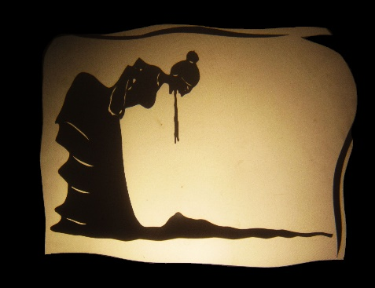
Images created by Reb Caputo

- SEVERAL MONTHS later, Perrigo realised he had been conned and he had Mary Bateman arrested. She was put on trial and found guilty. She was sentenced to be hanged but claimed to be pregnant. The judge ordered that she be examined by a panel of married women. No one wanted to do it, and he had to lock the courtroom doors to stop the married ladies running away.

- Mary was found not to be pregnant and she was hanged three days later. Her body was taken to the Leeds infirmary and people queued round the block to come and look at it. The hospital raised £30, charging three pence a look.
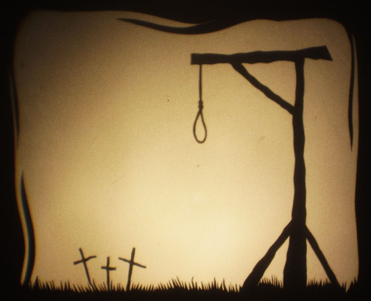
Image created by Reb Caputo

- Later, the body was dissected. The dissections were public and people were charged money to watch. A famous surgeon called William Hey cut open her eye. This lecture was for ladies only and raised eighty pounds.
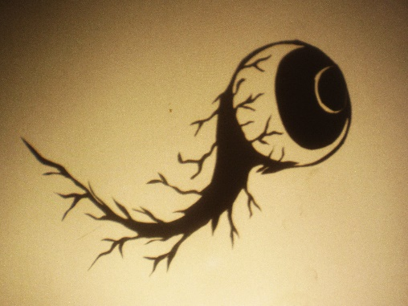
Image created by Reb Caputo

- Mary’s tongue was pickled and kept in the Bolling Hall museum until the 1930s, when it had rotted so badly it was thrown away. Her skin was tanned and sold to people who wrote in to ask for a strip of it. Her skeleton was also preserved and can be seen today in the Thackray Medical museum.

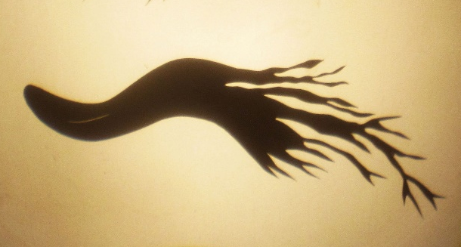
Image created by Reb Caputo

