
Categorising Museum Objects Activity

Instructions
1. Print out the images of collection objects and object categories on pages 2 to 11.
2. Cut out the object images.
3. Give each group a set of the object categories sheets and object images. Pupils need to put
the image of the object under the correct collection. Some of the objects will fit into more than one category, ask the pupils which ones they think may fit into more than one and explain their reasoning.

Differentiation
- This activity can be made easier by removing some of the images and collection suggestions.
- It can be made more difficult, or longer, by printing out any other images from MyLearning.org and adding them in to the activity.
- Rather than giving out the object categories, ask the pupils to come up with their own, based on the objects. If this is done in small groups, an interesting discussion can be had around the different category ideas they come up with for the same objects.
- Activity could be done as a whole class or class could be split into smaller groups where each group has 3-4 categories to organise.

Discussion Ideas
- Do the pupils agree with the given categories?
  - Are there any they would change, remove, or new ones they would add in?

- These categories have been created by curators in museums.
  - Do you think categorizing objects in this way is useful?
  - Are there better ways to organize museum collections?

Answers
Tiger: Natural History, World Cultures
Pikachu: Toys and childhood, World Cultures (Japan)
Telephone: Industry and Technology
Kingfisher: Natural History, Local history
Toy train: Toys and childhood, Industry and Technology
Train painting: Art, Industry and Technology
Locomotive: Industry and Technology, Local History (Leeds -Hunslet train)
Leeds Civic Hall Souvenir: Local History, Art
Snowy painting: Art
Japanese Kimono: World Cultures, Art
Totem Pole: World cultures, Art, Natural History
Jacquard Loom; Industry and Technology, Local History

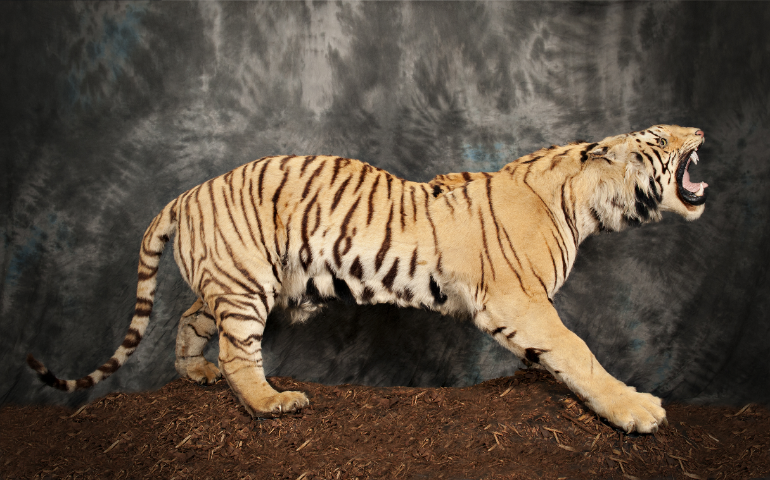
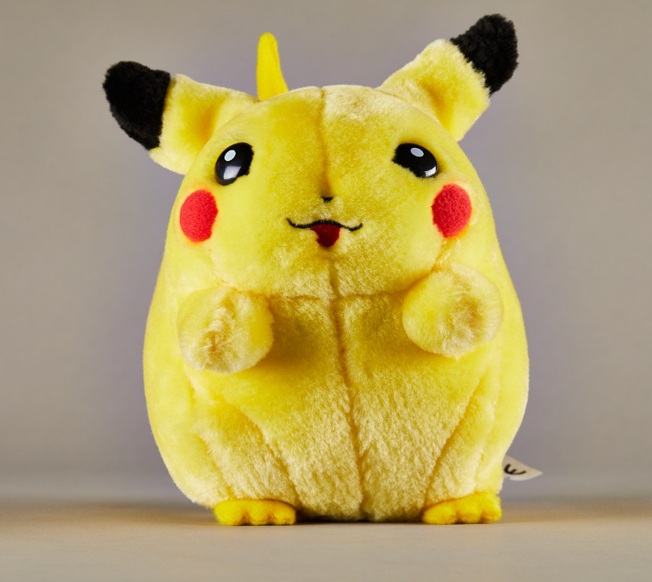
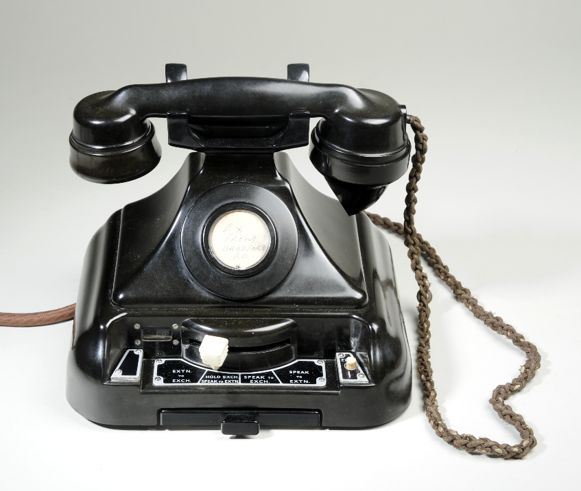
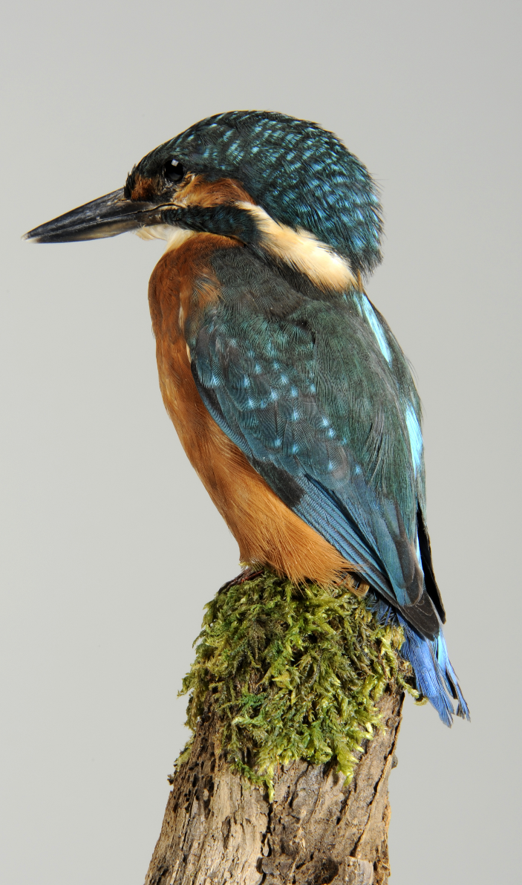
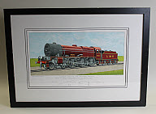
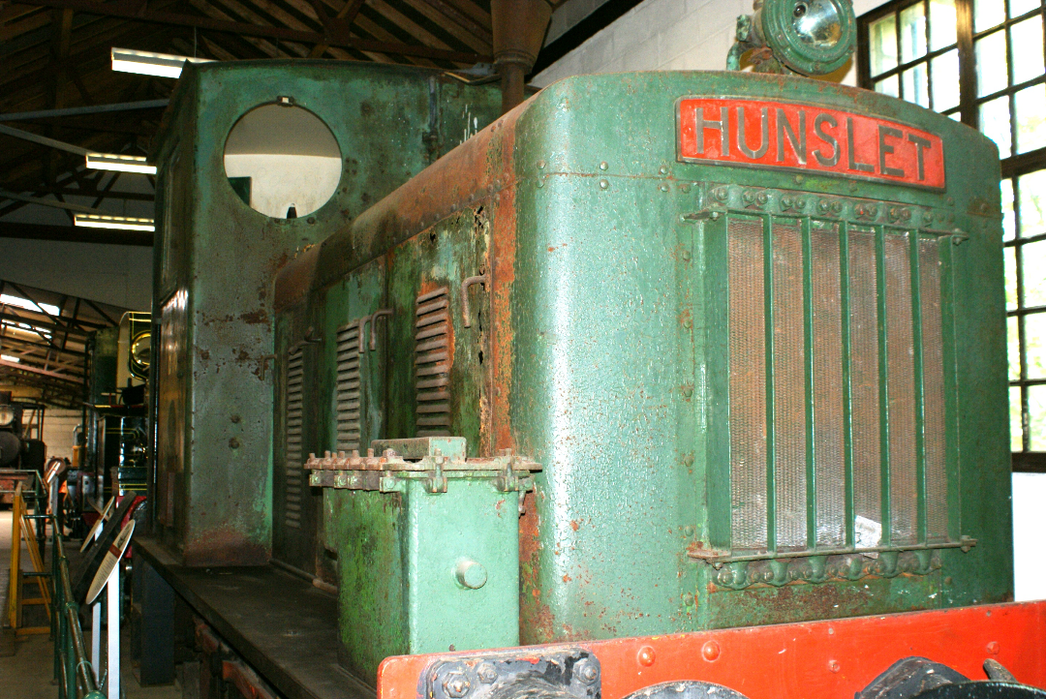
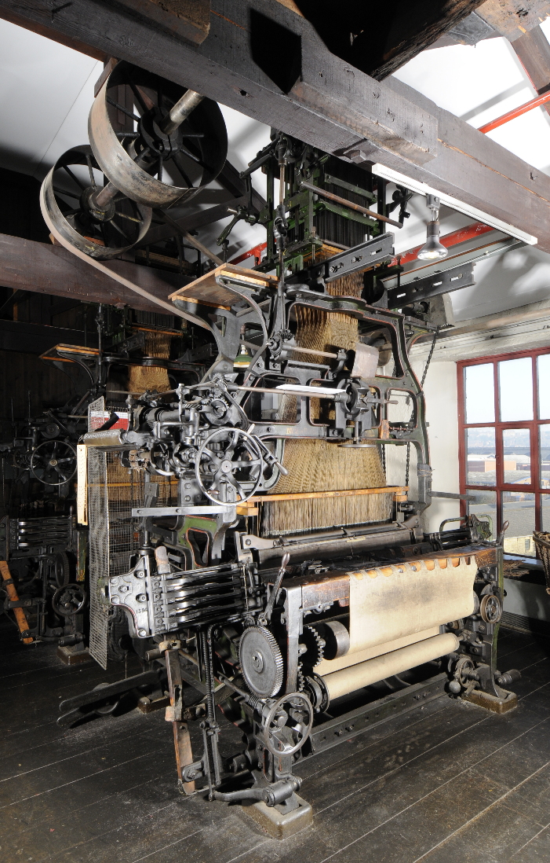
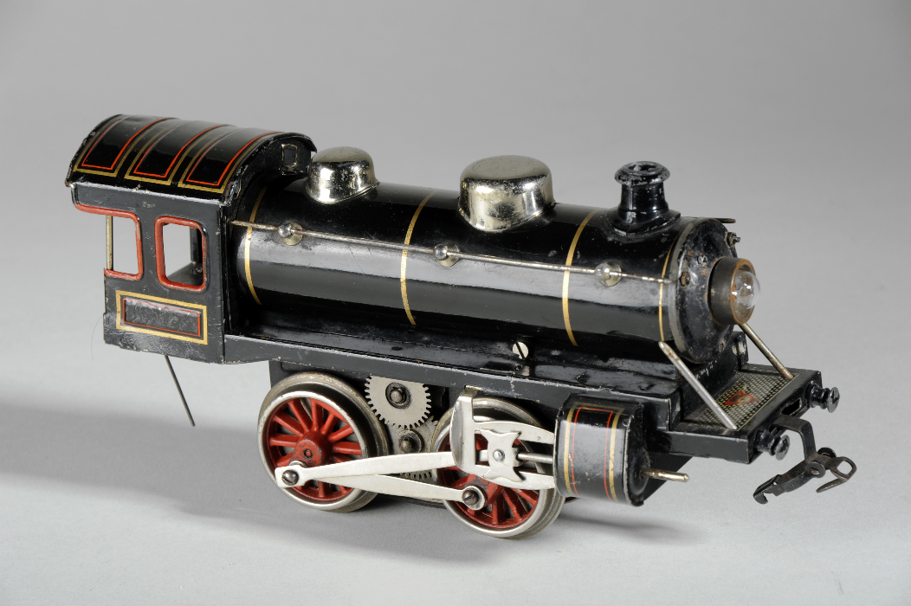
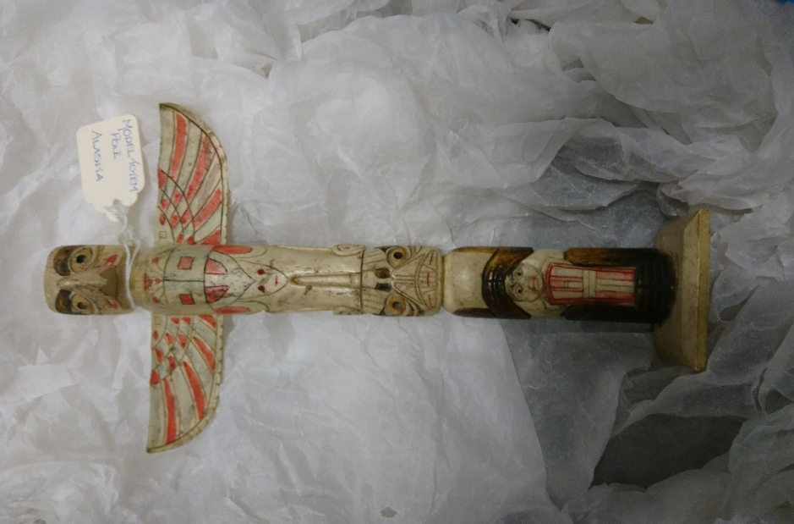
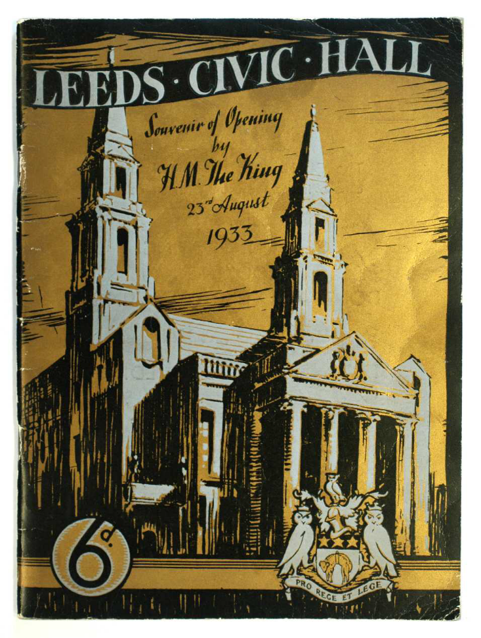
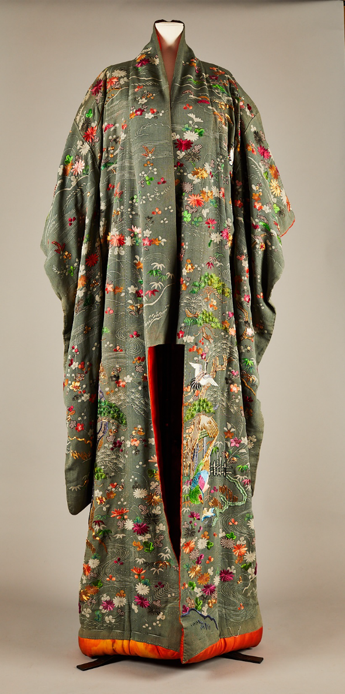
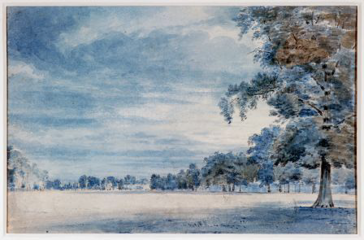
Natural History

Art

Industry and Technology

Toys and Childhood

Social History

Local History

World Cultures

